**[alpine hydro project]**

**Goal**: *Quantifying the contribution of alpine glacier meltwater to mountain-block recharge using microbiological markers and environmental isotopes*

**METHODS**

**Site description**

We sampled alpine springs, streams, and end-member water sources (rain, snow, and glacier ice) from two glacier systems: Mount Hood National Forest (MH), Oregon, and Glacier National Park (GNP), Montana, USA [Miller et al., 2021] (**Figure 1**). These systems host different bedrock and meteorological conditions, influencing mountain block recharge (MBR). MH is a volcanic system in the Cascades composed of young, permeable lavas and deposits left by pyroclastic flows and lahars from the Pleistocene (~30 ka) through the Holocene [Nathenson, 2004; Scott et al., 1997]. Rapid meltwater discharge rates (< 6 m3 s-1) and prior aqueous chemistry and isotopic analyses suggest that alpine springs are recharged beyond their immediate watersheds [Jefferson et al., 2006; Nathenson, 2004; Tague & Grant, 2009]. Although MH glaciers are rapidly retreating (~25% area loss since 2000), many remain active and accessible [Bakken-French et al., 2024]. GNP is found in the Livingston and Lewis Range of the Rockies, where Precambrian sedimentary rocks from the Belt Supergroup underlie glacier ice [Horodyski et al., 1983]. Unlike MH, the low-porosity bedrock in GNP limits MBR to fracture flow or karst-like pathways within carbonate-rich formations. GNP receives less precipitation than MH since Pacific moisture is deposited as rain and snow in the Cascades [Jefferson et al., 2006]. Glacier retreat in GNP is extensive (26 of 150 named glaciers remaining), and a total loss is predicted by 2100 [Bosson et al., 2019; Fagre et al., 2017; Hall & Fagre, 2003].

**Water sample collection and abiotic analysis**

Water samples were collected during several field campaigns between 2016 and 2019 (July 2016, October 2016, July to August 2017, July to August 2018, and September 2019) [Miller et al., 2021]. At MH, 38 unique springs/streams (n=54) and 34 end-member sources (glacial ice, glacial melt, snow, snow algae, and rain) were sampled. GNP samples include 22 unique springs/streams (n=33) and 11 end-members (glacier ice, glacial melt, snow, and snow algae). Site details, including locations and descriptions, are provided in a supplementary table(**Table S-TBD1**). Sampling sites were selected by Miller et al. [2021] using published maps, satellite imagery, input from local scientists and staff, and relevant literature [Nathenson, 2004; Wollenberg et al., 1979], spanning diverse elevations, geological histories, and aspects (**Figure 1**). When springs were inaccessible, samples were taken from nearby spring-fed streams. For each site, water profile measures for temperature, pH, conductivity, turbidity, dissolved oxygen, and oxidation-reduction potential (ORP) were gathered using a YSI Professional Plus multiparameter meter (YSI, Inc.). Water samples were collected using a peristaltic pump and filtered *in situ* through sterile 0.22 µm polyethersulfone (PES) membranes (Sterivex) into triple-rinsed Nalgene bottles. Liquid samples were stored in coolers during fieldwork and at 4°C in the laboratory.

Samples (filtrate) for isotope analysis were processed on a Triple Water Isotope Analyzer (Los Gatos Research, Inc., Model: 911-0034) at the Purdue Stable Isotope Facility [Miller et al., 2021]. Stable water isotope values (δ18O and δ²H) were reported relative to the Vienna Standard Mean Ocean Water–Standard Light Antarctic Precipitation scale. Aqueous chemistry samples (250 mL) were analyzed at the New Mexico Bureau of Geology and Mineral Resources via ion chromatography and inductively coupled plasma optical emission spectrometry using EPA methods (Method 300.0 and 200.7, respectively). All analyses were completed within two months of collection. We provided a complete summary of aqueous geochemistry results (mg/L) and sampling dates in **Table S-TBD2**.

Miller et al. [2021] applied a Bayesian Monte Carlo isotope (δ18O and δ²H) mixing model to estimate the fractional contributions of end-member water sources (glacier ice, fᵢ; snow, fs; and rain, fr) in each spring/stream (**Table S-TBD3**). Briefly, this approach kept or rejected randomly generated source fractionations from a prior probability density function based on a statistical likelihood value informed by data collected [Arendt et al., 2015]. The model assumes δ18O and δ²H values are parametric, with prior source fractions constrained such that fᵢ + fs + fr = 1 in MH and fᵢ + fs = 1 in GNP, where each source has an equal probability of contributing between 0 and 1. Springs and streams were classified as “glacially influenced” if fᵢ exceeded 0.60, a threshold identified previously through sensitivity analysis [Miller et al., 2021]. The highest fᵢ value was kept for sites sampled more than once.

**DNA collection and isolation**

Microorganisms from springs and streams were collected on 0.22 µm PES membrane filters in the field or from unfiltered samples processed in the laboratory (250 mL to 3 L of water per site) [Miller et al., 2021]. Field filters were preserved in RNAlater and stored at -20 °C until DNA extraction. In the lab, sample water was vacuum filtered through pre-combusted (450 °C, 12 h) 0.22 µm GF/F filters (Sterlitech) under sterile conditions. Snow and ice samples were melted at room temperature before filtration. Before extraction, RNAlater was removed from filters by rinsing with 18.2 MΩ cm-1 water. DNA extraction followed the PowerLyzer PowerSoil Kit (Qiagen, Inc.) protocol, and DNA quality was assessed via electrophoresis. DNA concentrations were quantified using a Qubit™ dsDNA HS Assay Kit (Molecular Probes) and Qubit™ Fluorometer (Invitrogen). Samples with DNA concentrations above 0.01 ng µL-1 were sequenced at the University of Minnesota Genomics Center (UMGC) (**Table S-TBD4**). Negative controls (unused filters or 18.2 MΩ cm-1 water) submitted for sequencing failed quality control; no DNA was obtained.

**Nucleic acid preparation, amplification, and sequencing**

Samples submitted to the UMGC were prepared for Illumina high-throughput sequencing using a MiSeq instrument and 2x300 bp chemistry. To evaluate microbial taxonomy, this workflow amplified the V4 hypervariable region of the bacterial 16S SSU rRNA gene using 515F (5′-TCGTCGGCAGCGTCAGATGTGTATAAGAGACAGGTGCCAGCMGCCGCGGTAA-3′) and 806R (5′-GTCTCGTGGGCTCGGAGATGTGTATAAGAGACAGGGACTACHVGGGTWTCTAAT-3′), adding Illumina flow cell adapters and dual indices through a secondary amplification reaction [Gohl et al., 2016]. Complementary amplicon libraries were prepared using primers **___** and **___** targeting the **V9** hypervariable regionof the eukaryotic 18S SSU rRNA. A total of **_**.**__** million (**_**,**___**,**___**) raw reads were obtained from 88 indexed, 16S rRNA samples, whereas **_**.**__** million (**_**,**___**,**___**) raw reads were obtained from 55 18S rRNA samples.

**Data processing**

Amplicon sequences were processed in mothur (v1.48.1) following the MiSeq SOP [Kozich et al., 2013; Schloss et al., 2019]. Briefly, we combined forward and reverse reads within each sample, quality-filtered these assembled reads, trimmed reads, and removed ambiguous base calls. We removed chimeras using vsearch (**v2.13.3**), aligned reads to the SILVA database (**v.132**), and combined reads into operational taxonomic units (OTUs) using a 97% similarity threshold appropriate for broad-scale ecological trends of interest [Glassman & Martiny, 2018].

**Community analysis & statistics**

All statistical analyses were performed in R (R Core Team, 2021) and were applied to microbial taxonomy and abundance data imported via *phyloseq* [McMurdie & Holmes, 2013; e.g., Sauer et al., 2022]. Mitochondrial and chloroplast 16S rRNA sequences were removed, resulting in a final dataset of 1,031,667 reads (63,059 OTUs) across 72 samples, including biological replicates.

Environmental variability

We created a principal component analysis (PCA) biplot (*ggbiplot*) to investigate abiotic differences between springs and streams (n = 50; 17 GNP, 33 MH) [Vu, 2011; e.g., Kohler et al., 2020]. Variables with right-skewed distributions were log₁₀(x)-transformed (**Figure S1**). Before dimensional reduction, strongly collinear variables (Pearson’s r > 0.9) were excluded from our 16S rRNA dataset to minimize redundancy: bicarbonate (HCO₃), calcium carbonate (CaCO3), specific conductivity (SPC), and magnesium (Mg) were removed due to their near-linear relationships with calcium (Ca); total dissolved solids (TDS) due to collinearity with strontium (Sr); and both chloride (Cl) and potassium (K) due to their strong correlation with sodium (Na) (**Figure S1**). Despite collinearity (r > 0.9), silica (SiO2) and Na were kept due to their distinct biogeochemical roles – SiO2 as an indicator of silicate weathering and microbial-mineral interactions [e.g., Ghezzi et al., 2022], and Na as a tracer of ion exchange processes (e.g., rock-water interactions). We tested for significant differences between glacier systems (MH vs. GNP) using PERMANOVA (*adonis2*, 999 permutations) on a Euclidean distance matrix [Oksanen et al., 2018]. Homogeneity of dispersion was tested using PERMDISP (*betadisper*; 999 permutations).

Alpha diversity

After removing singleton OTUs, we excluded samples with < 8,000 reads. This threshold was informed by a rarefaction curve and the correlation between richness and sample depth across sequencing batches (**Figures S2, S3**). We then rarefied our working dataset to 7,511 reads (90% of the minimum depth), resolving uneven sequencing efforts [Schloss & McMahon, 2024]. Our rarefied dataset contained 337,995 reads (16,320 taxa) from 45 springs and streams (27 MH, 18 GNP). Observed richness and Shannon diversity were calculated in *phyloseq* and contrasted between glacier systems using a t-test or Wilcox rank sum test if data were parametric or non-parametric, respectively, per autoplot in *ggfortify* [Tang et al., 2016]. We tested correlations between fractional glacier ice (fᵢ) and diversity metrics using Pearson’s product-moment correlation and two-tailed permutation tests (9,999 iterations). A Welch’s t-test compared mean fᵢ between GNP and MH. All models assumed independence, randomness, and unbiased sampling. Biological replicates (n = 2–3 for 10 of 33 sites) were treated as independent measurements to better represent ecological variability. However, to determine if aggregating replicates would affect our conclusions, we averaged alpha diversity metrics by site and compared statistical outcomes to non-aggregated data. Negligible differences in p-values, effect size, and standard deviations support our non-aggregated analysis (see *Results*).

Following protocols outlined in Sperlea et al. [2021], we used a machine learning framework to quantify how community composition covaried with 18 environmental variables (including fi). Taxa significantly associated with upper/lower tertiles of environmental variables were identified (*multipatt*, *indicspecies*; p < 0.05), and our subsequent dataset was Hellinger-transformed to limit the impact of high-abundance OTUs [Cáceres & Legendre, 2009]. We used these data to train a RandomForest model that projected microbial membership into one-dimensional space. Environmental drivers were compared by quantifying the variance explained by microbial membership (R2). We cross-validated R2 estimates 10 times and performed triplicate analyses to assess the reliability of our findings [e.g., Sperlea et al., 2021].

To complement alpha diversity and multivariate approaches, we used a linear discriminant analysis effect size (LEfSe) to identify major taxa over- or under-represented across recharge sources and glacier systems (MH vs. GNP) in our rarefied dataset (LDA scores > 2.5; Kruskal–Wallis p-value < 0.01). This method was completed using *microbiomeMarker* and added specificity to our investigation of microbial responses to environmental inputs [Cao et al., 2022]. Bioindicators of recharge sourcing were evaluated in MH, exclusively, since the distribution of fi in GNP prevented comparisons. Additionally, our LDA score threshold was less stringent than recent literature (LDA scores > 3.5) [e.g., Lamarche-Gagnon et al., 2024] to reveal broader patterns of bacterial abundance.

Beta diversity

For robust cross-site comparisons, OTUs absent in > 90% of samples and samples with low read depth (< 6,000 reads) were removed (**Figure S4**). A variance-stabilizing transformation (VST) was applied to normalize our OTU table [Love et al., 2014]. VST stabilizes variance across different abundance levels and transforms data into near-normal distributions, improving comparisons [Badri et al., 2020]. Our working beta diversity dataset contained 3,587 OTUs from 45 samples (27 MH, 18 GNP). Due to moderate variability, biological replicates (n = 2–3 for 9 of 33 sites) were treated as independent communities (see *Results*). Bray-Curtis dissimilarity distance matrices from our VST dataset were used to determine the similarity between these replicates (**Table S1**). Compositional distances between springs and streams were visualized via PCA. Significant environmental correlates of PC1 and PC2 were identified using linear regression and redundancy analysis (*vegan*, 9,999 permutations, Bonferroni-corrected p < 0.05) [Oksanen et al., 2020]. Distinctions between geographic and local clusters – based on Bray-Curtis dissimilarity – were tested using PERMANOVA and *vegan*’s adonis2. Homogeneity of dispersion was assessed using PERMDISP (*betadisper*; 999 permutations). To complement our PCA, we performed hierarchical cluster analysis (method = ward.D2) on our previously generated Bray-Curtis dissimilarity matrix, visualizing clusters in a dendrogram.

**RESULTS**

**Spring and stream environments differ within and between alpine glacier systems**

To determine how glacier meltwater sourcing (fi) influences microbial community composition, we first characterized underlying physical and geochemical conditions across springs and streams. PCA revealed significant abiotic differences between MH and GNP (F = 20.19, R2 = 0.34, p = 0.001). A biplot showcases the directionality of these differences, with GNP and MH clusters roughly separated along PC1 and PC2 due to higher SiO2 and ORP in MH, and greater fi, pH, and elevations in GNP (**Figure 2**). Several variables (e.g., Sr, temperature, SO4, Ca, DO, HCO3, CaCO3, SPC, and Mg) predominately contributed to PC1, reflecting within-system variability among MH and GNP samples. Among these variables, DO showed a somewhat inverse relationship with Sr, temperature, Ca, and collinear solutes, suggesting redox-driven geochemical processes. Local outliers – particularly geothermally active warm springs at MH – help demonstrate how alpine environments vary at several spatial scales.

**Bacterial community membership varies spatially and is poorly explained by glacial meltwater sourcing**

To quantify differences in bacterial community structure, we produced two alpha-diversity estimates: Richness (the total number of unique OTUs) and Shannon’s diversity index, which accounts for both richness and the evenness of OTU abundances. Observed richness (t = -3.77, p = 0.0005, mean = 1602 OTUs in MH and 981 OTUs in GNP, respectively) and Shannon’s diversity (W = 127, p = 0.007, mean = 6.11 in MH and 5.56 in GNP) were higher in springs and streams from MH (**Figure 3**). Additionally, both metrics were more variable among MH samples than those from GNP [sd = 613 OTUs vs. 408 OTUs and 0.912 vs. 0.722, respectively]. While inter- and intra-system variation suggests that microbial communities may respond to environmental inputs, neither alpha-diversity metric correlated with fi at MH or GNP, despite significantly higher fi for springs and streams in the latter (t = 6.09, p = 2.7e-7, mean = 0.76 vs. 0.42) (**Figure 4**).

Aggregating biological replicates by site (averaging richness and Shannon’s diversity) produced similar results. While p-values (Richness Δp = -0.0004; Shannon Δp = -0.006), mean differences (Richness Δ = +131; Shannon Δ = +0.20), and standard deviations (e.g., for OTU richness, MH Δsd = -43; GNP Δsd = -53) changed slightly, conclusions were consistent. Consistency among replicates supports our decision to treat each as an independent sample, supporting a more accurate representation of spring and stream variability (**Figures S5, S6**).

We used a supervised machine learning framework to compare the influence of glacial meltwater sourcing (fi) and other physical and geochemical features on bacterial community structure. Using an iterative pipeline developed by Sperlea et al. [2021], we found that bacterial communities were generally more predictive of environmental conditions in MH than in GNP (mean R2 = 0.53 vs. 0.17, t = -9.90, p = 2.8e-16) (**Figure 5**). Among the predictors tested, elevation, ORP, pH, and fi generated R2 values below geographic averages, suggesting a negligible ecological impact (**Figure 5**). In contrast, the predictive power of bedrock constituents and redox conditions (Cl⁻, Na⁺, Sr²⁺, K⁺, SO₄²⁻, SiO₂, DO, and Mg²⁺) varied between systems, with R2 differences greater in MH than GNP (mean differences = +0.44 to 0.64). CaCO3, HCO3-, Ca2+, SPC, temperature, and TDS were the strongest predictors of OTU abundance (R2 values exceeded both geographic means). Our findings show that rock–water interactions and subsurface flow conditions may shape alpine spring microbiomes and obscure glacial meltwater signatures.

**Bacterial communities may diverge geographically and between adjacent sites in response to hydrological conditions and geochemical inputs**

To investigate differences in microbial community composition between spring sand streams (beta diversity), we performed a PCA on our variance-stabilized 16S rRNA dataset. Samples from MH and GNP formed distinct clusters (R2 = 0.089, F = 4.20, p = 0.001), suggesting that system-scale features influenced bacterial community structure (**Figure 6**). Geographic clustering is expanded upon in our Ward’s (D2) dendrogram, which shows minimal overlap between mountain systems and presents Warm Springs as distinct MH outliers (**Figure S7**). However, heterogeneity in within-group variation (F = 5.04, p = 0.04) means that these results should be interpreted with caution as they may reflect an uneven sample distribution. Additionally, PC1 and PC2 explained 26.2% of the total variance, highlighting the influence of unmodeled environmental or spatial factors on beta diversity. Replicates showed considerable variability (Bray-Curtis dissimilarity = 0.38 – 0.84, justifying their use as independent data points (**Figure S8**; **Table S1**).

To explore potential drivers of community composition, we added environmental variables significantly correlated with PC1 and PC2 (p < 0.05) to our PCA plot (**Figure 6**). Several geochemical variables – SiO₂, Cl, K, Na, and Sr – were highly collinear (Pearson’s r > 0.9; **Figure S9**) and positively associated with Warm Springs, distinguishing these geothermally active sites from others. DO and SO4 vectors showed an inverse relationship and better explained local-scale variation. While higher fi values distanced GNP bacterial communities from MH, this separation likely reflects broad geographic differences rather than a glacial sourcing signal given how disparate fi values are between MH (0.04-.86) and GNP (0.5-0.99). This analysis suggests that environmental conditions driven by subsurface hydrology and geochemistry (e.g., solute availability) may play a formative role in community composition.

Springs and streams can be grouped into local regions (e.g., the Palmer region situated in southwest MH). At MH, these regions form distinct bacterial communities (R2 = 0.29, F = 1.70, p = 0.001), where Warm Spring communities may diverge in responses to greater solute concentrations (e.g., SO4, SiO2, Na, and Sr), higher temperatures, decreased DO, and elevated fi (p < 0.5) (**Figure S10a**). When removing Warm Springs outliers, the distance between community compositions is significantly explained by Sr2+, HCO3-, and CaCO3 (**Figure S10b**). Nevertheless, heterogeneity in within-group dispersion (p < 0.001) suggests that these regional clusters are unreliable. Therefore, bacterial communities may respond to distinct subsurface conditions unique to each spring or stream, even in the same region. Notably, GNP communities did not cluster by region and showed no significant correlations with physicochemical variables (**Figure S11**).

**Microbial community composition suggests that glacial recharge is best modeled as a continuous variable reflecting various subsurface inputs and environmental filtering**

We recovered 63 unique phyla from 45 springs and streams. Ten phyla were responsible for 90% of the total relative abundance. In all samples, Proteobacteria or Bacteroidota were the most abundant taxa, comprising 17–78% and 6–53% of each sampled community, respectively (**Figure S12**). These phyla were followed by Verrucomicrobiota, Acidobacteriota, Planctomycetota, Actinobacteriota, and Cyanobacteria (**Figure S13**). At a Class level, Bacteroidia were the most common, followed by Gammaproteobacteria and Alphaproteobacteria(**Table S2, Figure 7**). Samples, particularly Warm Springs, contain distinct Classes that could reflect local stressors or mixed inputs. For example, Nanoarchaeia are predominantly found in Warm Springs, and Cyanobacteria, prevalent in Glacier Melt samples, are shared between glacially and non-glacially recharged communities (**Figure 7, Figure S14**). By Order, Burkholderiales, Chitinophagales, Sphingomonadales, and Flavobacteriales were the most abundant (**Table S2**). *Flavobacterium* were ubiquitous, overshadowing other high-abundance genera: *Rhizorapis*, *Ferruginibacter*, and *Polaromonas*. Across tax, abundance did not noticeably differ between precipitation- and glacier-sourced (fi > 0.60) sites (e.g., **Figure S15**). However, LEfSe analysis suggests that certain bacterial Classes (Anaerolineae and Bacteroidia) and an Order (Chitinophagales) help drive differences in microbial assembly at MH under different recharge regimes (LDA scores > 2.5; p < 0.01) (**Figure S16**). Geographically, GNP sites were enriched in Flavobacteriales. LEfSe did not yield indicator taxa for aspect, quadrant, and regional distinctions within glacier systems. Overall, structural comparisons suggest that glacier meltwater recharge may be best described as a continuous variable, where inputs can vary between springs and streams, and environmental filtering may shape microbial communities in subsurface flow paths.

Despite overlapping microbial community composition, bioindicators of meltwater recharge (MBR) and geographic location may persist in our non-rarefied alpha diversity dataset. Precipitation- (11,267 OTUs) and glacier meltwater-sourced (11,941 OTUs) samples contained 38.9% and 42.3% exclusive taxa, respectively (**Figure S17a**). Geographic differences were more apparent: Mount Hood (MH) had nearly twice as many OTUs as Glacier National Park (GNP) (14,150 vs. 7,931), with 59.3% exclusivity compared to 27.4% in GNP (**Figure S17b**). These results reveal large pools of both core and accessory bacteria across alpine springs and streams, where spatial differences may outweigh the importance of water source (precipitation vs. glacial meltwater).

**Eukaryotic communities show weak associations with modeled variables**

Alpha and beta diversity analyses were also performed on eukaryotic (18S rRNA) sequence data to expand our search for bioindicators and examine cross-Kingdom ecology. Normalization, inclusion criteria for biological replicates, metadata, and sample sizes – such as 35 rarefied samples (19 MH, 14 GNP) with 7,627 unique OTUs for alpha diversity – are detailed in **Supplementary Document 1**.

Observed richness was significantly higher in MH compared to GNP springs and streams, resembling bacterial trends (t = -2.54, p = 0.016; mean richness = 935 vs. 546) (**Figure S18**). However, Shannon diversity did not differ significantly between glacier systems (W = 105, *p* = 0.32; mean MH = 4.37, GNP = 3.88). Overall, eukaryotic diversity was lower than bacterial diversity in both systems. Similar to our 16S rRNA dataset, neither alpha diversity metric significantly correlated with fi (**Figure S19**). Additionally, our supervised machine learning pipeline [Sperlea et al., 2021] revealed poor predictive power for eukaryotic communities across both MH and GNP (mean R2 = 0.116 vs. 0.112, respectively) (**Figure S20**). In GNP, Sr was the strongest predictor (mean R2 = 0.38 vs. 0.04 for MH), whereas SO4 was most influential in MH (mean R2 = 0.53 vs. 0.09 for GNP). These results suggest that eukaryotic communities are less responsive to modeled environmental variables than bacteria, limiting their bioindicator potential.

A PCA of the 18S rRNA dataset showed no significant associations between the disparity in community composition (beta diversity) and fitted environmental variables (**Figure S1**). Given the collectively low explanatory power of modeled variables, we excluded eukaryotes from further bioindicator analysis and focused efforts on bacterial communities. Despite limited environmental associations, several dominant taxa were observed. Fungi (mean relative abundance = 19.8%), Ochrophyta (16.1%), and Streptophyta (10.4%) were the most abundant Phyla. At the class level, Bacillariophyta (11.5%), Embryophyceae (10.2%), Basidiomycota (7.5%), and Ascomycota (6.6%) were predominant. Microbial abundance at lower taxonomic levels resolutions are summarized in **Table S-TBD5**.

**FIGURES**

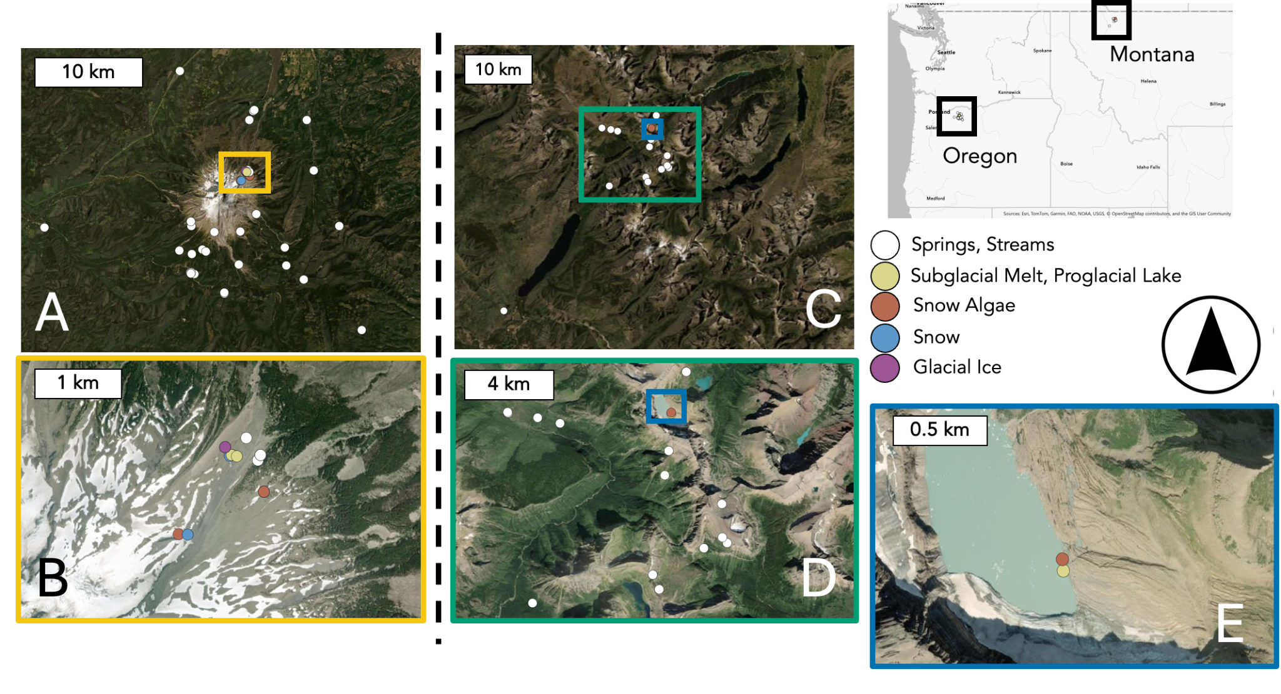

**Figure 1. The distribution of biological (16S rRNA) sampling sites**. Sampling sites contributing to our 16S rRNA dataset – distinguished by Sample Type (color) – from Mount Hood (MH; A,B) and Glacier National Park (GNP; C-E) [Miller et al., 2021]. Inset boxes correspond to zoomed images with identical border colors.

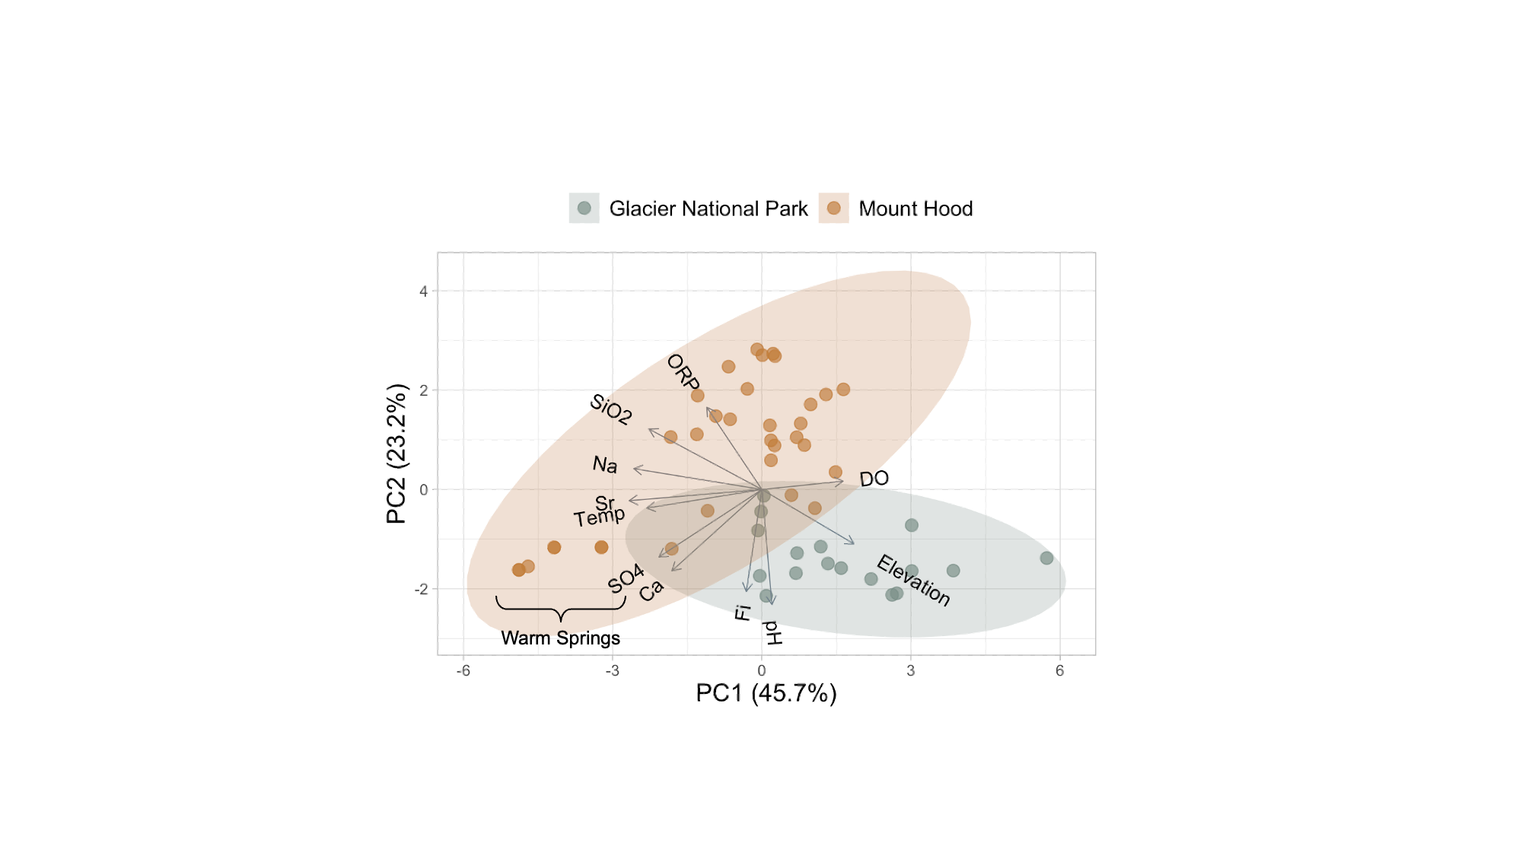

**Figure 2. Principal components analysis (PCA) of hydrogeochemical conditions across Mount Hood (MH) and Glacier National Park (GNP) springs and streams.** The first two components (68.9% variance explained) separate sites at regional (colors) and local scales, with vectors showing variable contributions. Covariates (HCO₃, CaCO₃, SPC, Mg, TDS, Cl, K) were removed due to collinearity (see *Methods*). MH’s geothermally active Warm Springs were called out as distinct outliers.

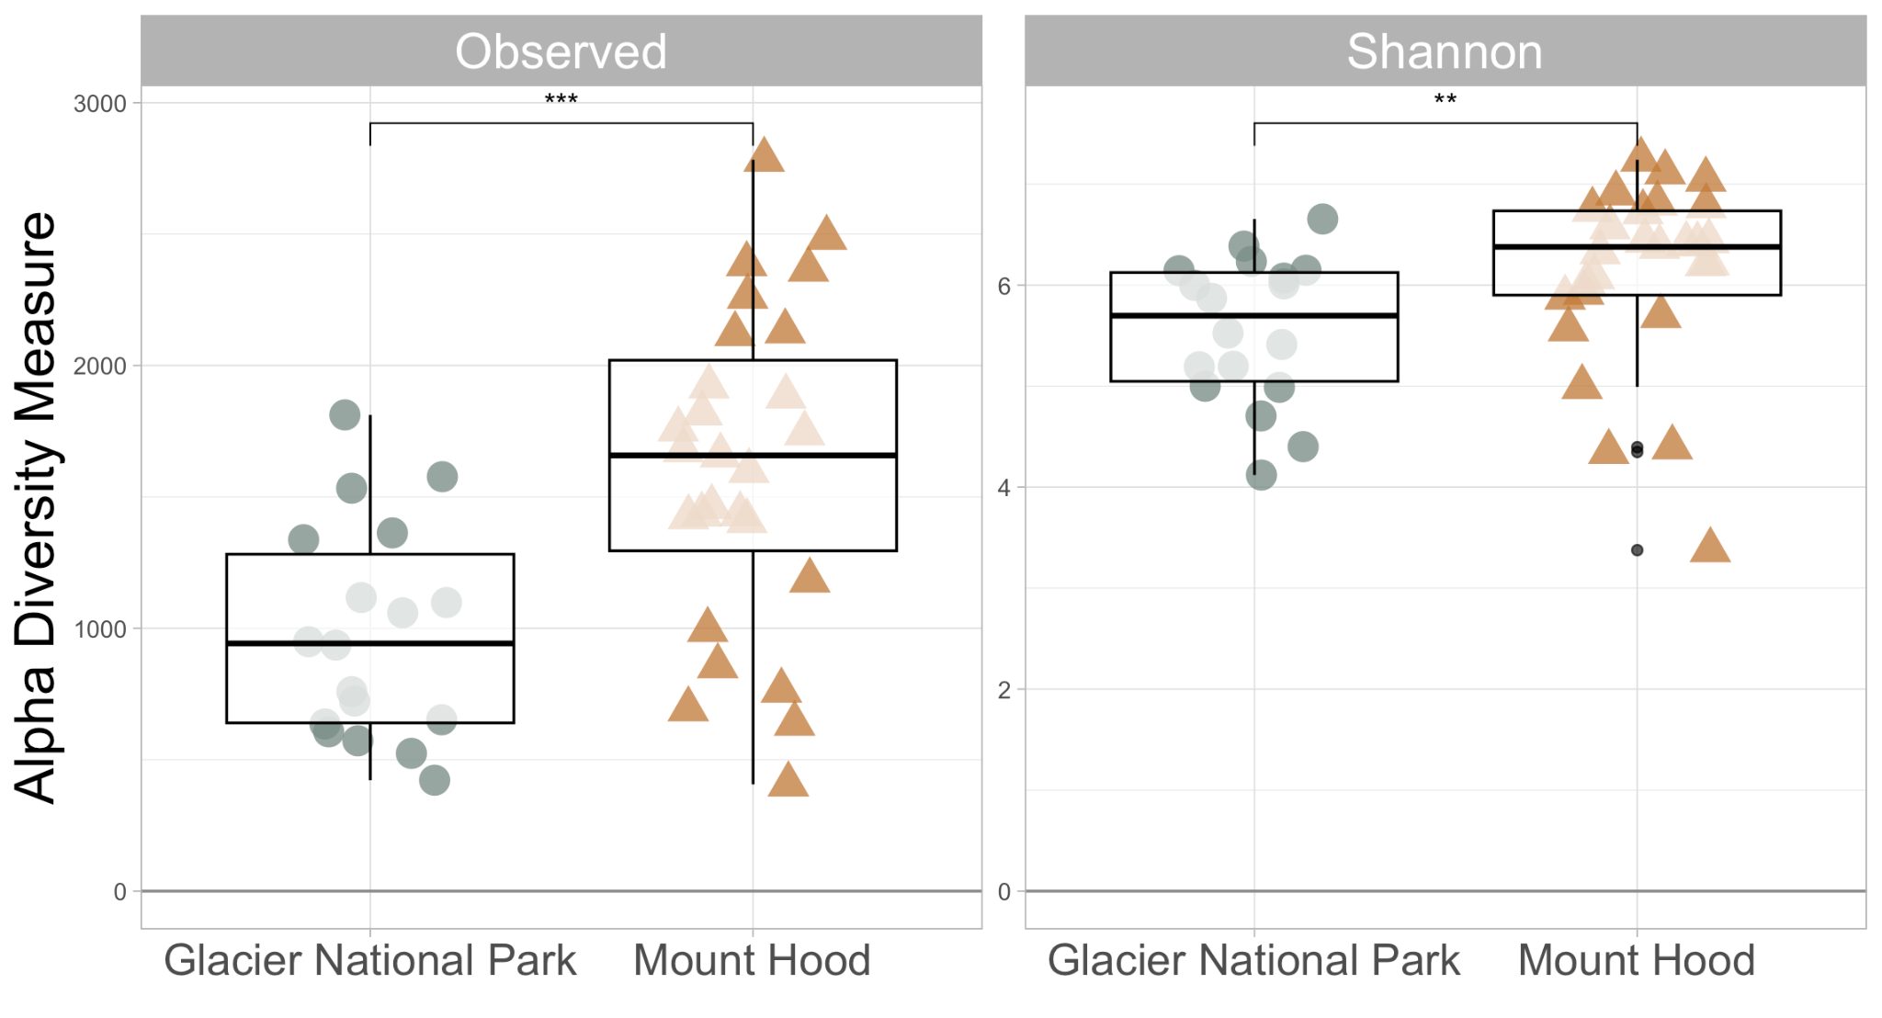

**Figure 3. Alpha diversity was greater, and data points were more widely distributed across Mount Hood**. Alpine springs and streams from Mount Hood (n=27) have greater richness and evenness than Glacier National Park counterparts (n=18). Black circles and lines represent means and 95% CIs, respectively. Asterisks capture the statistical significance of mean differences (***= p<0.001, *=p<0.05).

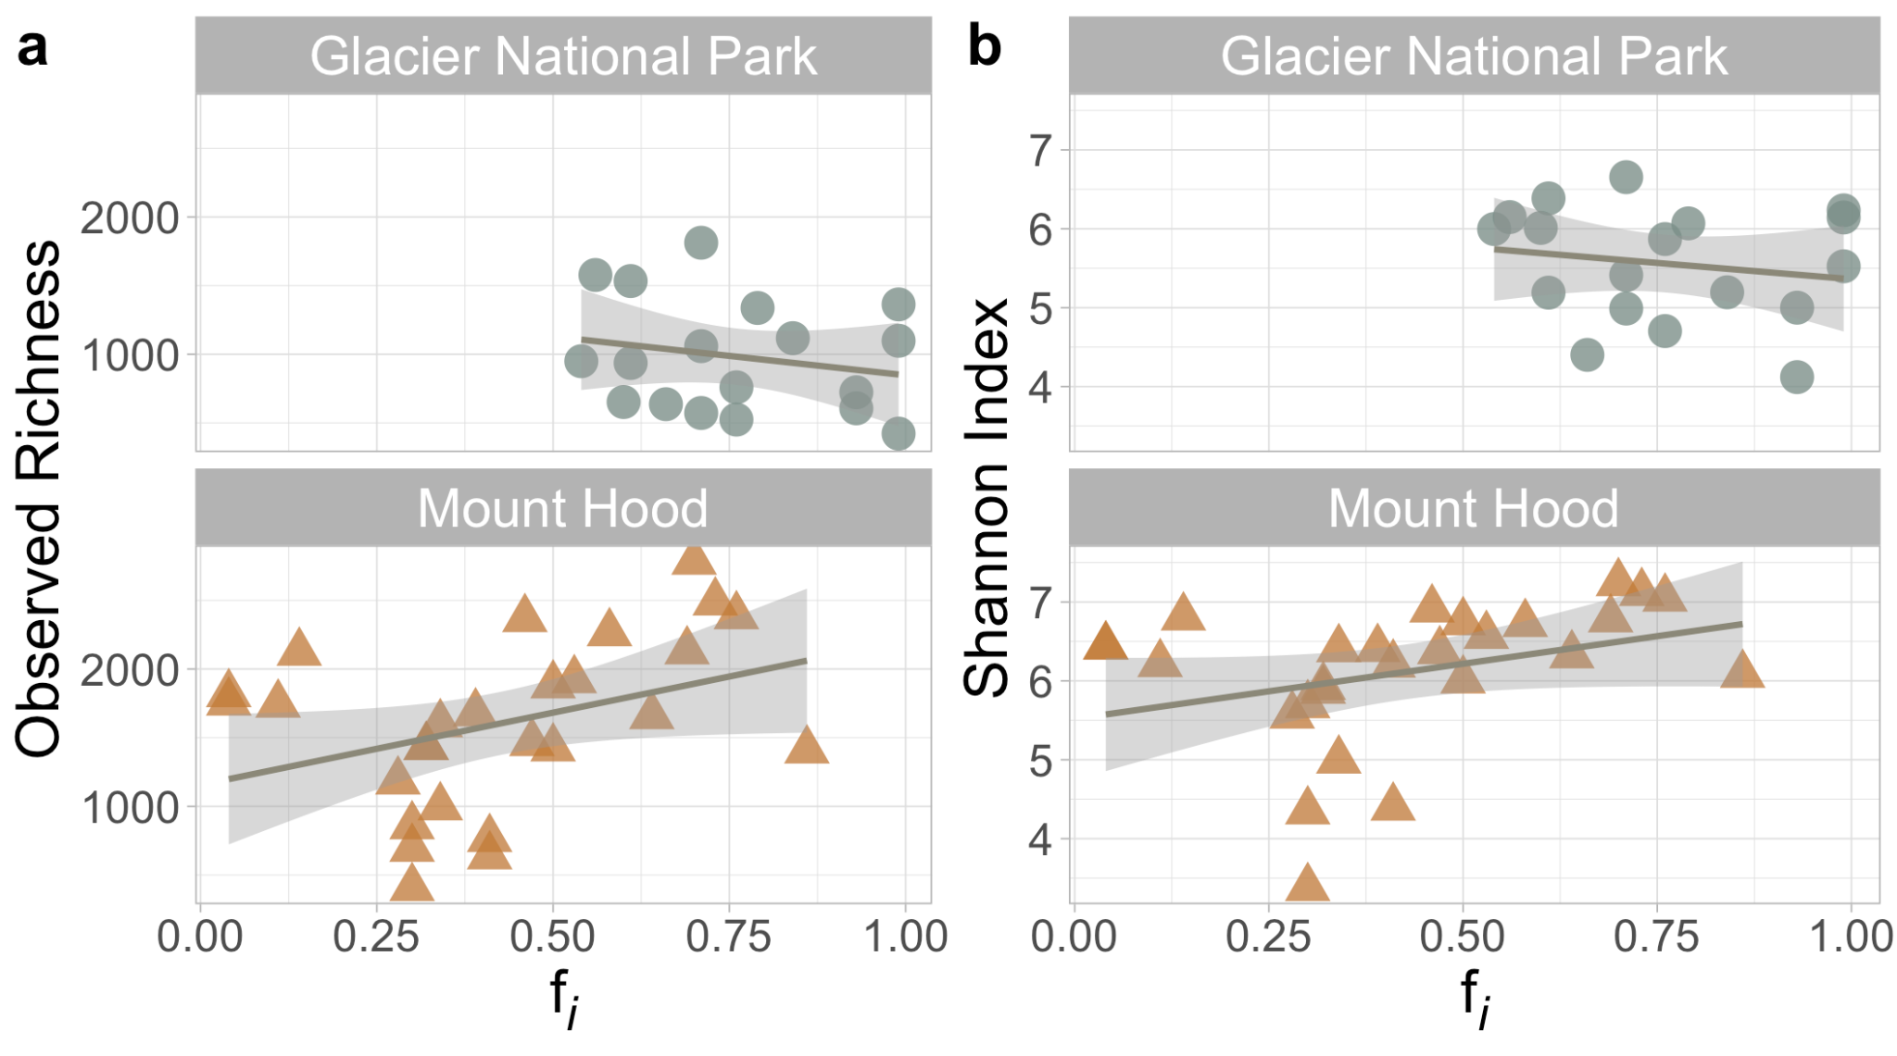

**Figure 4. Isotopic contributions of glacier ice to springs did not significantly explain alpha diversity**. Scatter plots illustrating the relationship between fractional contributions of glacier ice (fi) and (a) *richness* or (b) *Shannon’s diversity* between GNP (n=18) and MH (n=27) springs/streams. Positive and slightly negative correlations in MH and GNP lack significance (p>0.05). Nevertheless, observed richness significantly varied between glacier systems (p=0.040). Lines and gray boundaries represent linear regressions and 95% CIs.

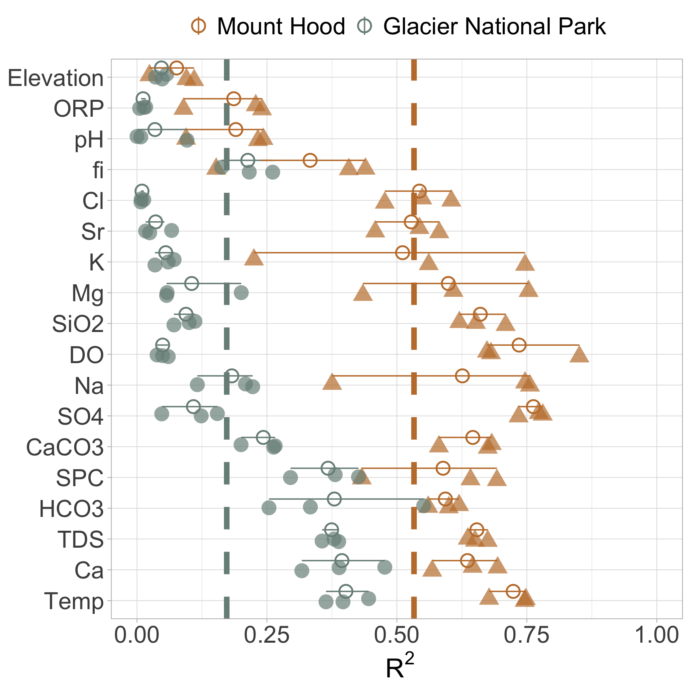

**Figure 5**. **Covariation (R2) of microbial community composition and selected environmental variables in MH and GNP**. (filled shapes and colors). Data points are technical replicates. Empty circles and lines represent means and 95% CIs, respectively. Dotted vertical lines – colored by glacier system – illustrate dissimilar geographic means (p=2.74 x 10-7) spanning all variables — abbreviations found in *Water sample collection and environmental measurements*.

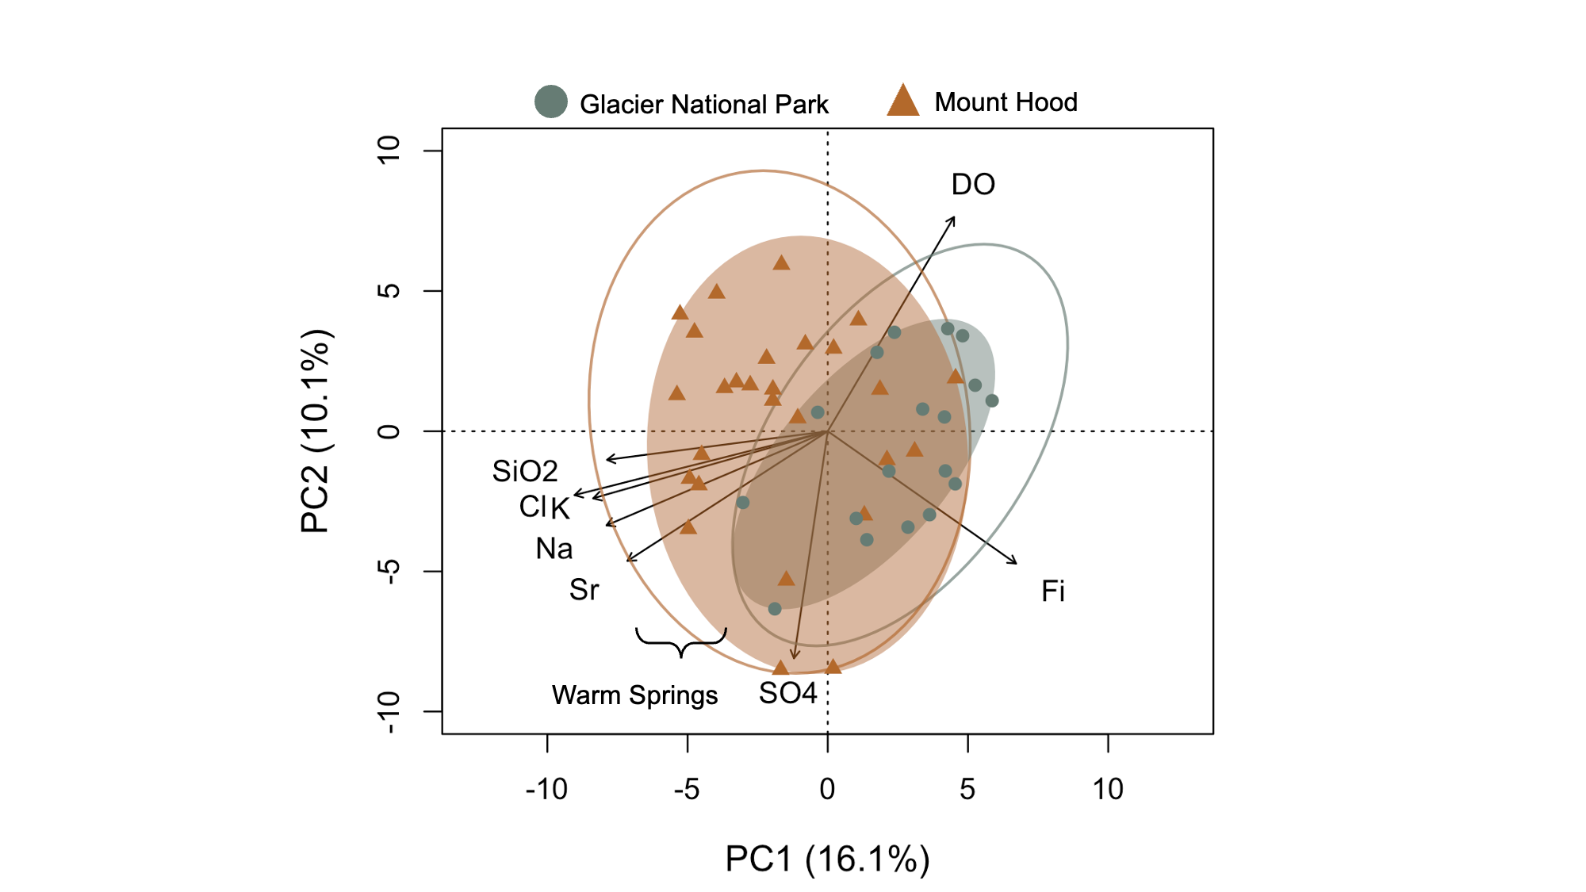

**Figure 6**. **Geographic separation drives beta diversity across Mount Hood and Glacier National Park springs and streams**. PCA of spring and stream bacterial samples grouped by geographic location (colors and shapes). The first two components explained 26.2% of the total variability. Fitted environmental variables represent significant linear regressions (p < 0.05) where we plotted PC1 and PC2 as a function of environmental measurements. Ellipses illustrate the standard deviation within MH or GNP.

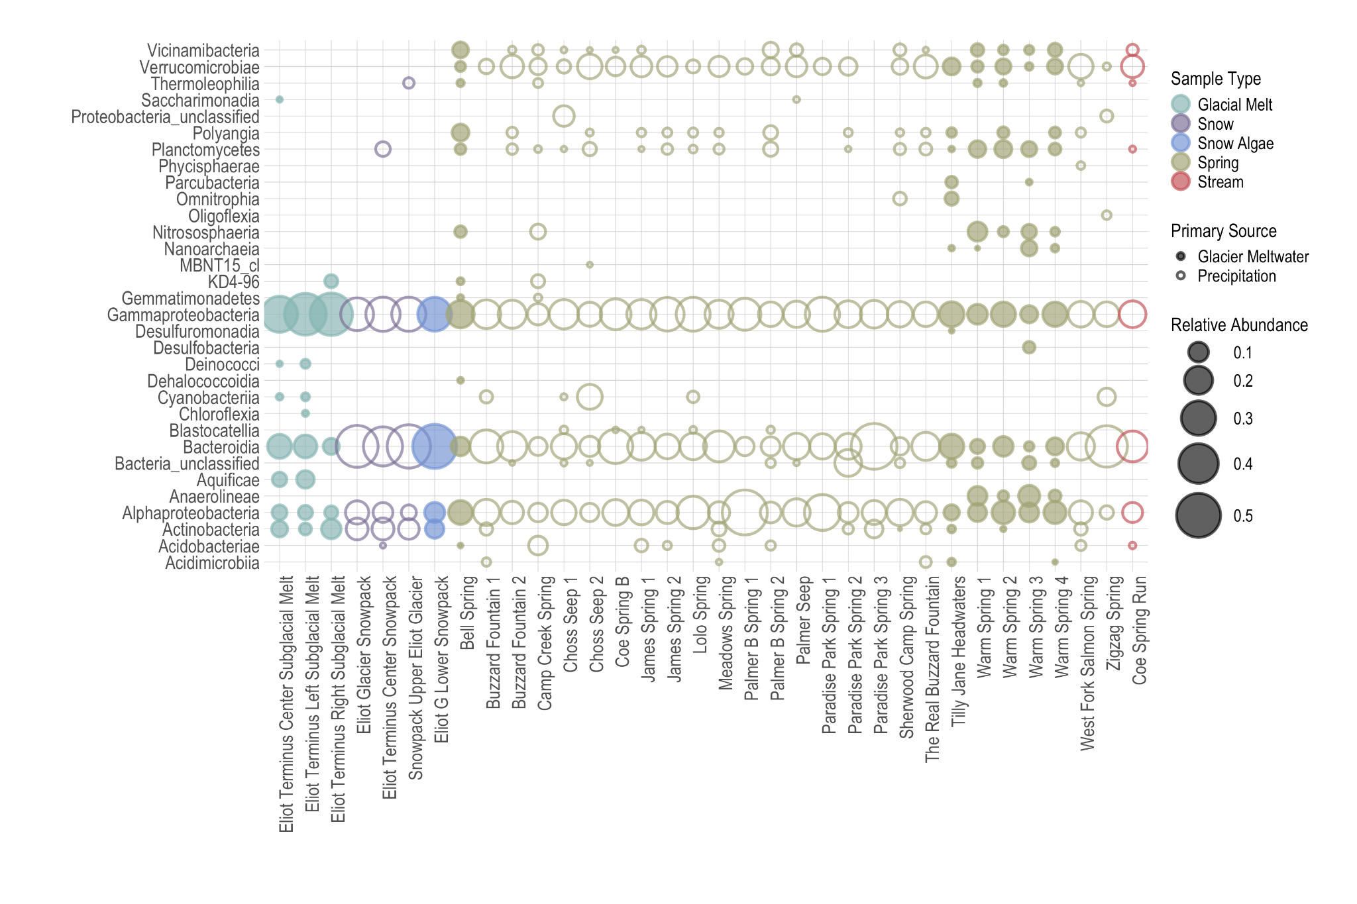

**Figure 7**. Abundance comparison of bacterial spring and stream communities [**shape** = predominant recharge source per Miller et al. [2021], color = sample type, size = relative abundance (fraction) of classes in the applicable sample (x-axis)]. OTUs – within each Class – were removed if they comprised < 2% of the total relative abundance in all samples. **Bolded Classes are mentioned in the text**.

**SUPPLEMENTALS**

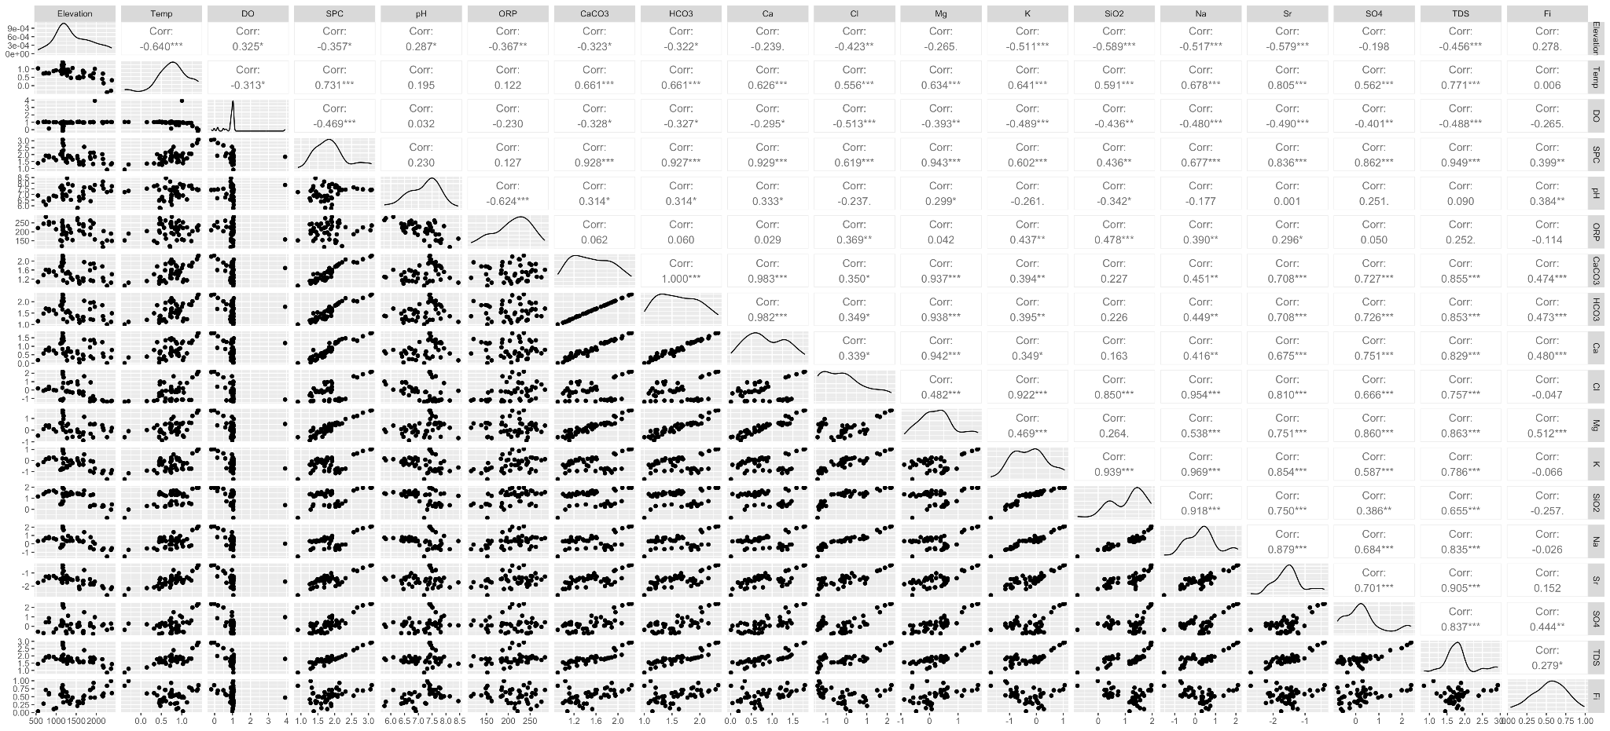

**Figure S1**. **Pairwise correlations and distributions of hydrogeochemical variables used in our abiotic PCA, after log₁₀(x+1) transformation**. The Upper triangle shows Pearson correlation coefficients (r). Lower triangle shows scatterplots presenting cross-variable interactions. Variables exhibiting strong collinearity (r > 0.9, highlighted in red) qualified for removal. Diagonal histograms show near-normal distributions, reflecting log10-transformation. This analysis informed variable selection to minimize multicollinearity while supporting biogeochemical interpretations (see *Methods*).

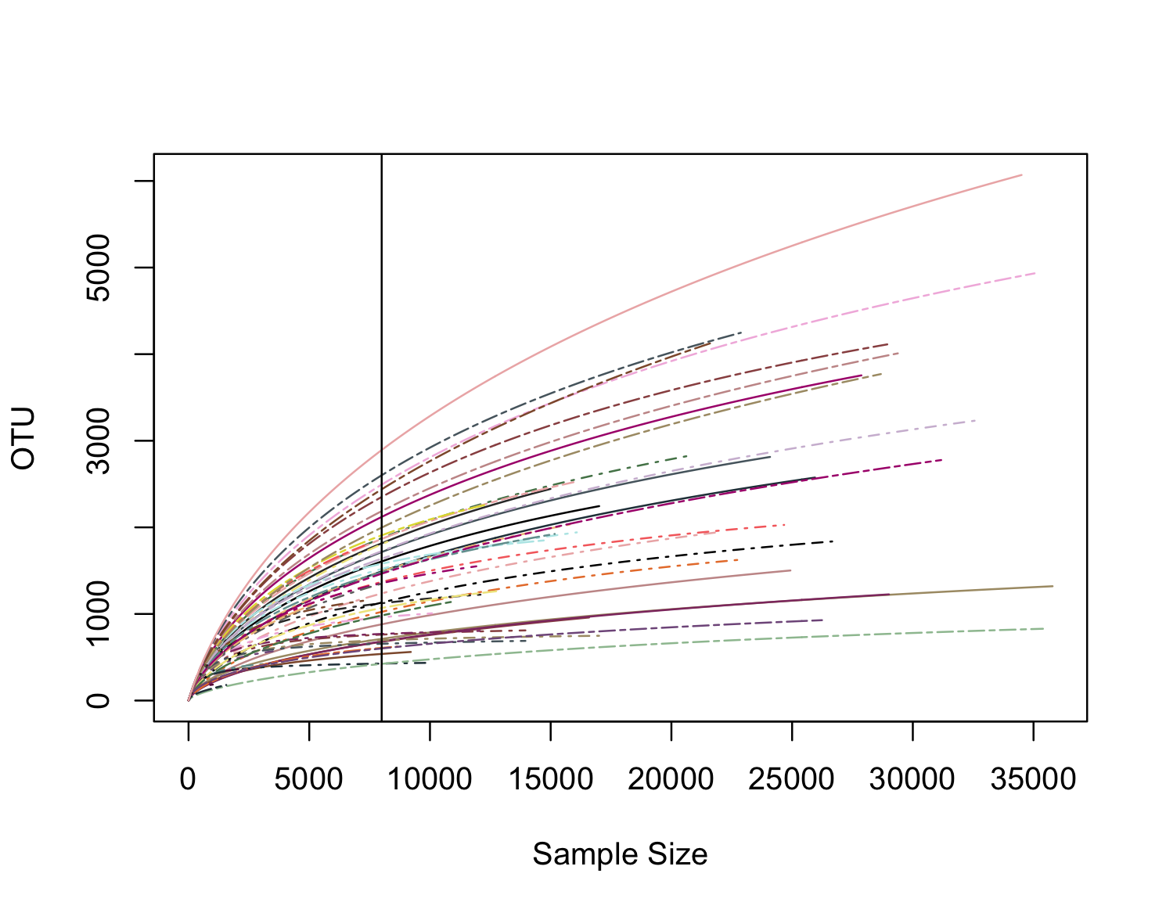

**Figure S2.** Rarefaction curve for alpha diversity analyses; Bacterial dataset (16S rRNA)

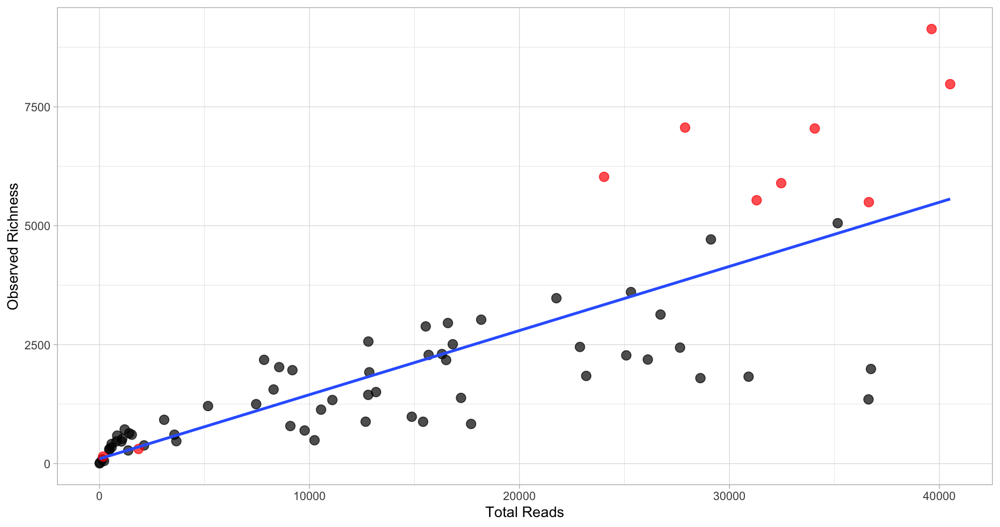

**Figure S3**. **Batch effect on richness**. Observed richness (i.e., total unique OTUs) in response to total 16S rRNA (V4) reads in each sample, where color highlights different sequencing batches. Pearson’s correlation between sequencing depth (Total Reads) and richness was statistically significant (p < 0.001, R2 = 0.64).

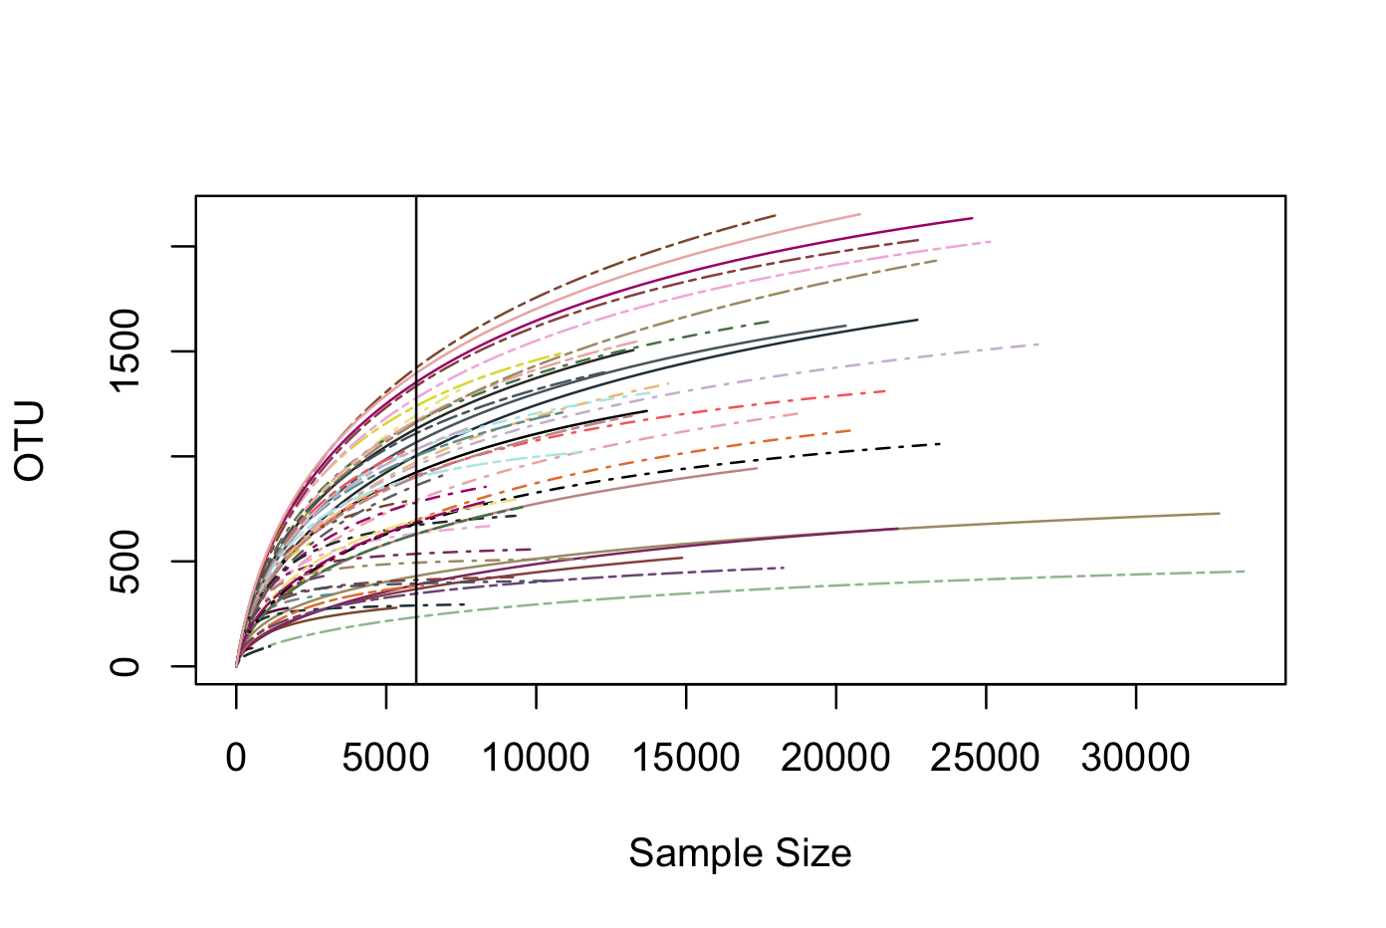

**Figure S4**. Rarefaction curve for alpha diversity analyses; Eukaryotic dataset (18S rRNA)

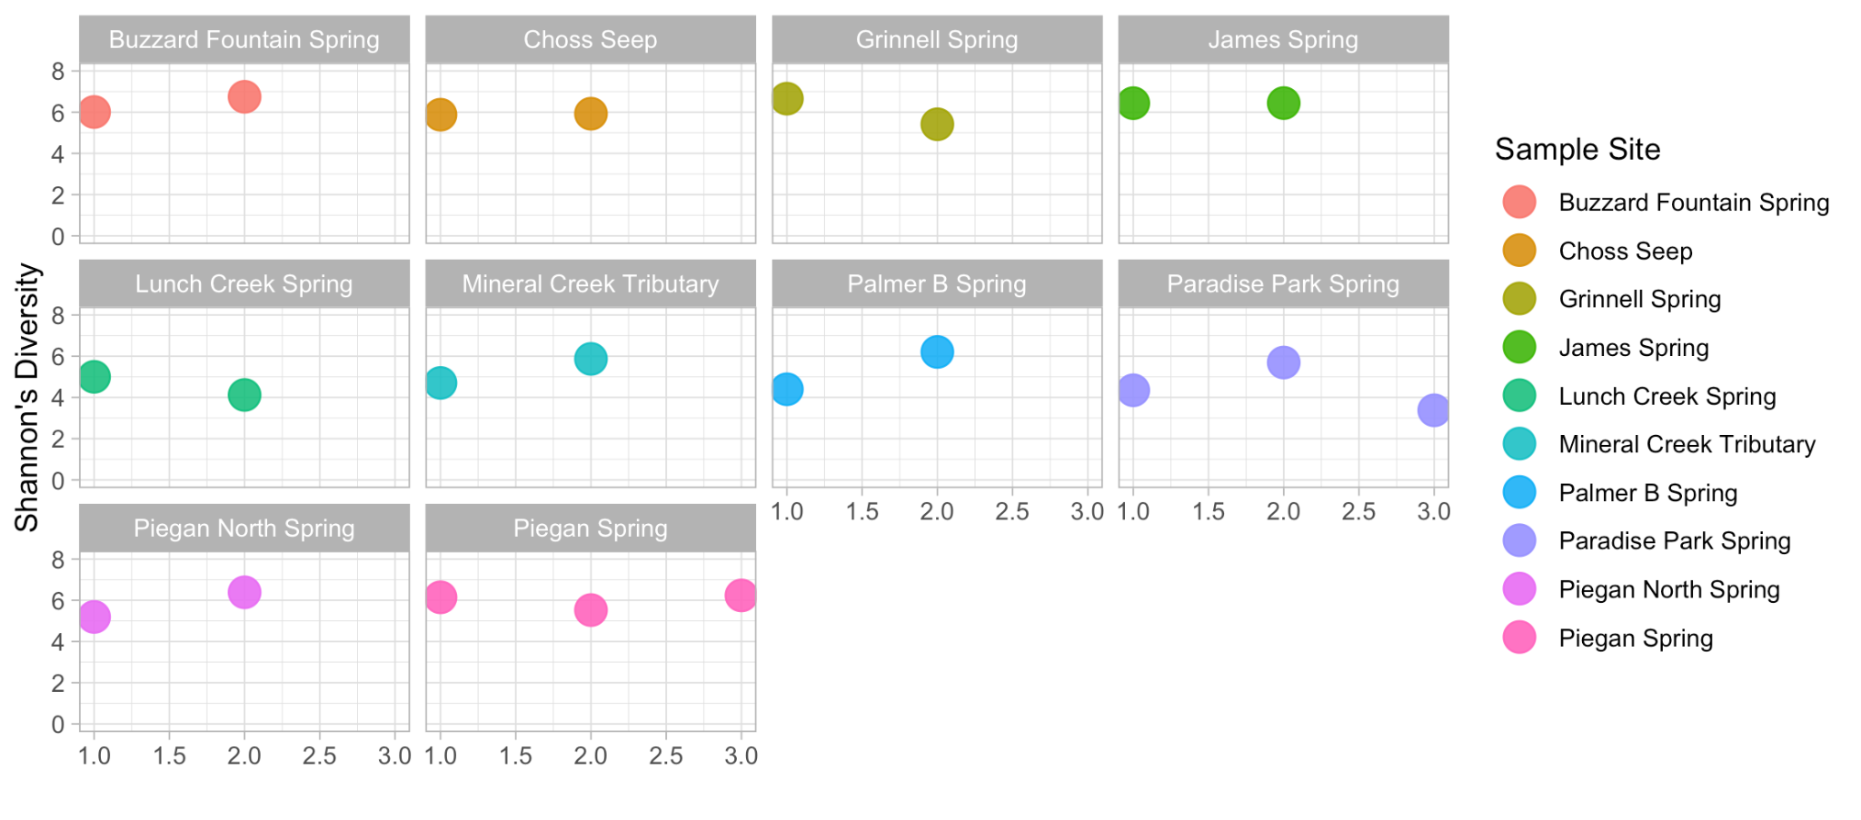

**Figure S5**. Variability in *Shannon’s diversity* between biological replicates (16S rRNA dataset). X-axis = Replicate # (1-3).

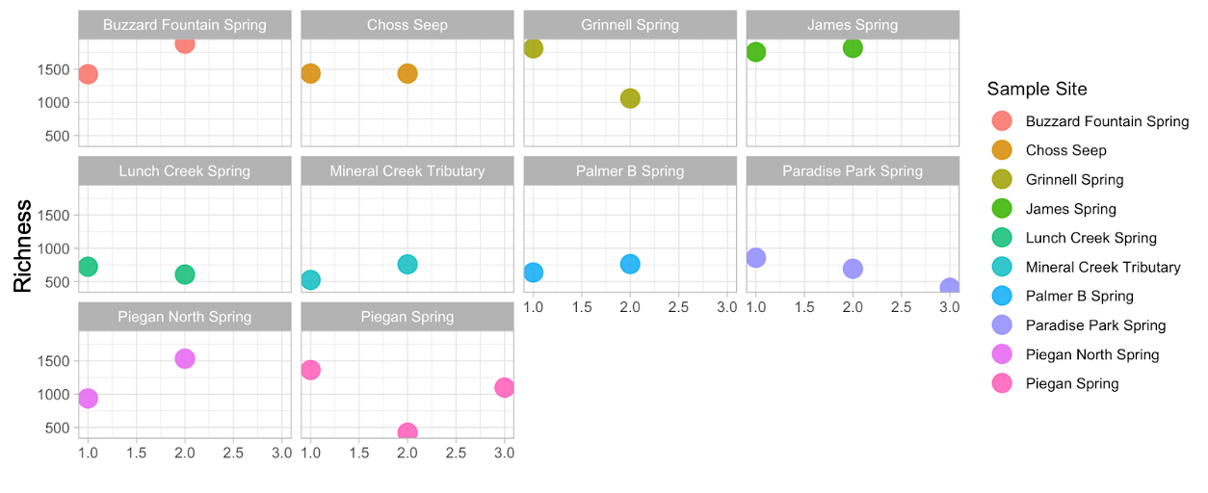

**Figure S6**. Variability in *Shannon’s diversity* between **biological replicates** (16S rRNA dataset). X-axis = Replicate # (1-3).

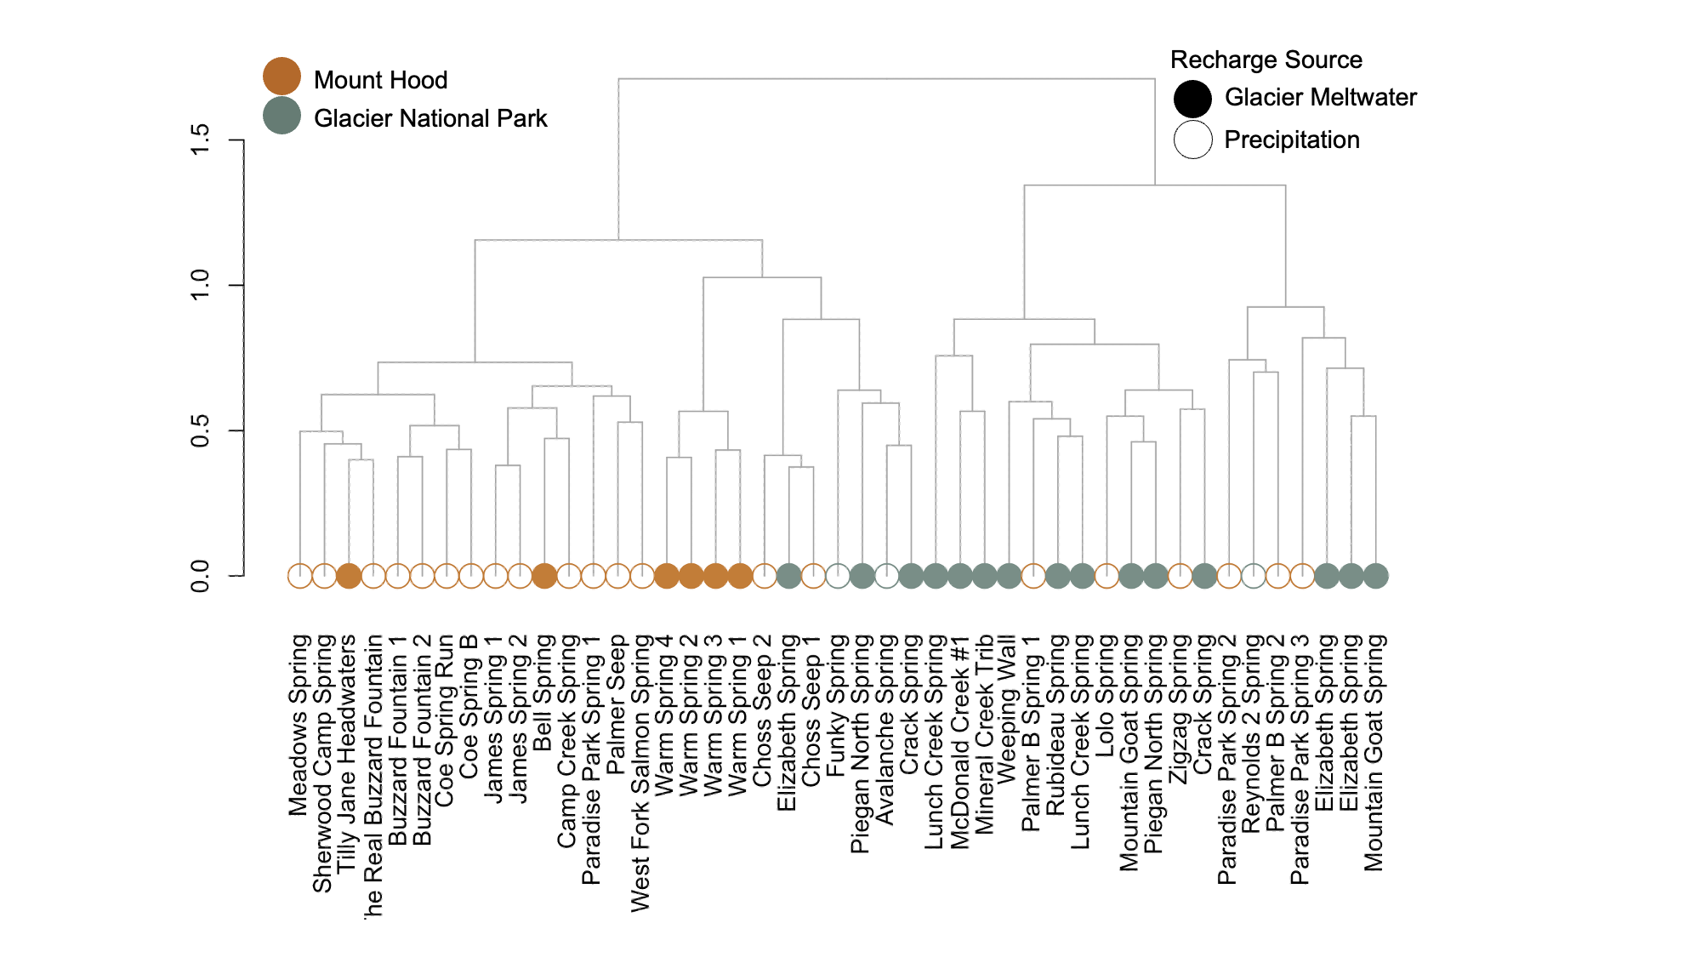

**Figure S7**. Hierarchical clustering of sample communities per *Bray-Curtis dissimilarity*. Y-axis = Level of variability at each branch-point (16S rRNA dataset).

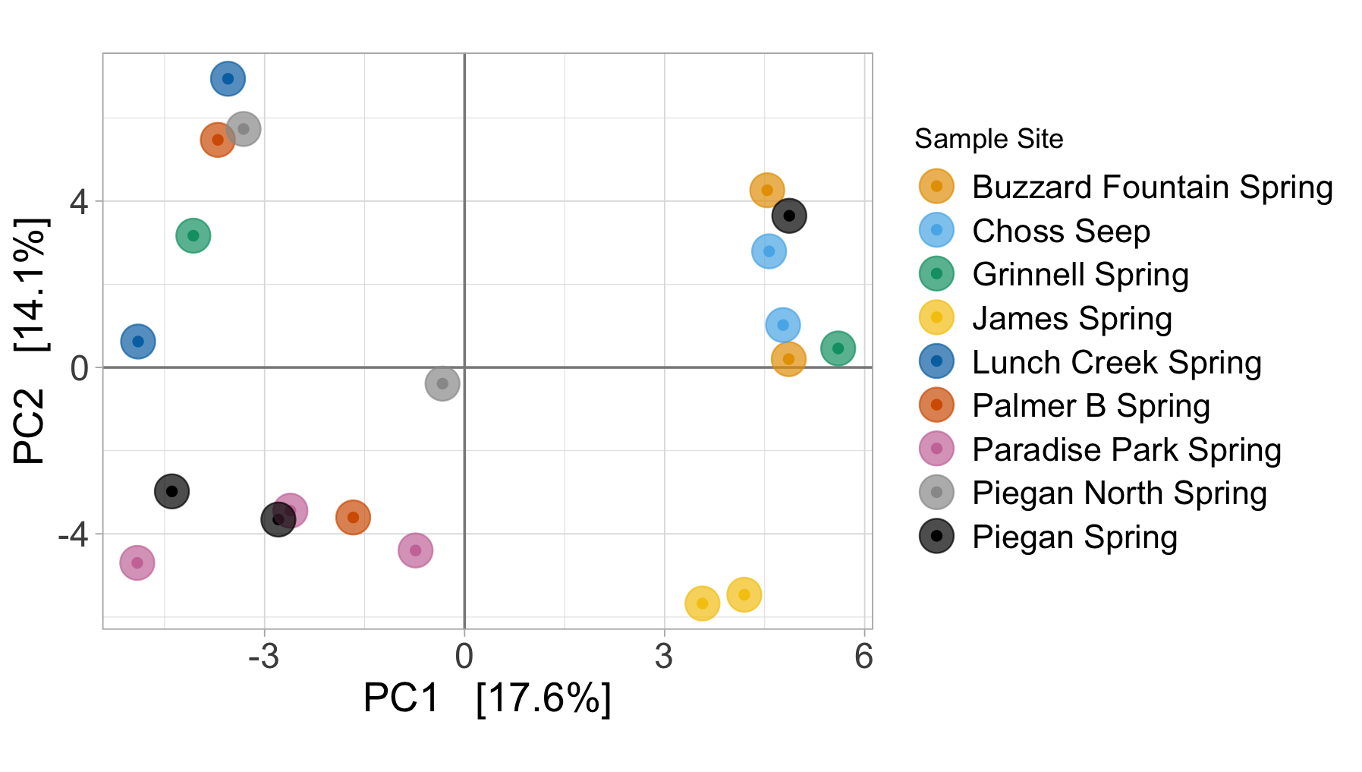

**Figure S8**. PCA demonstrating variability between **biological replicates** (16S rRNA dataset).

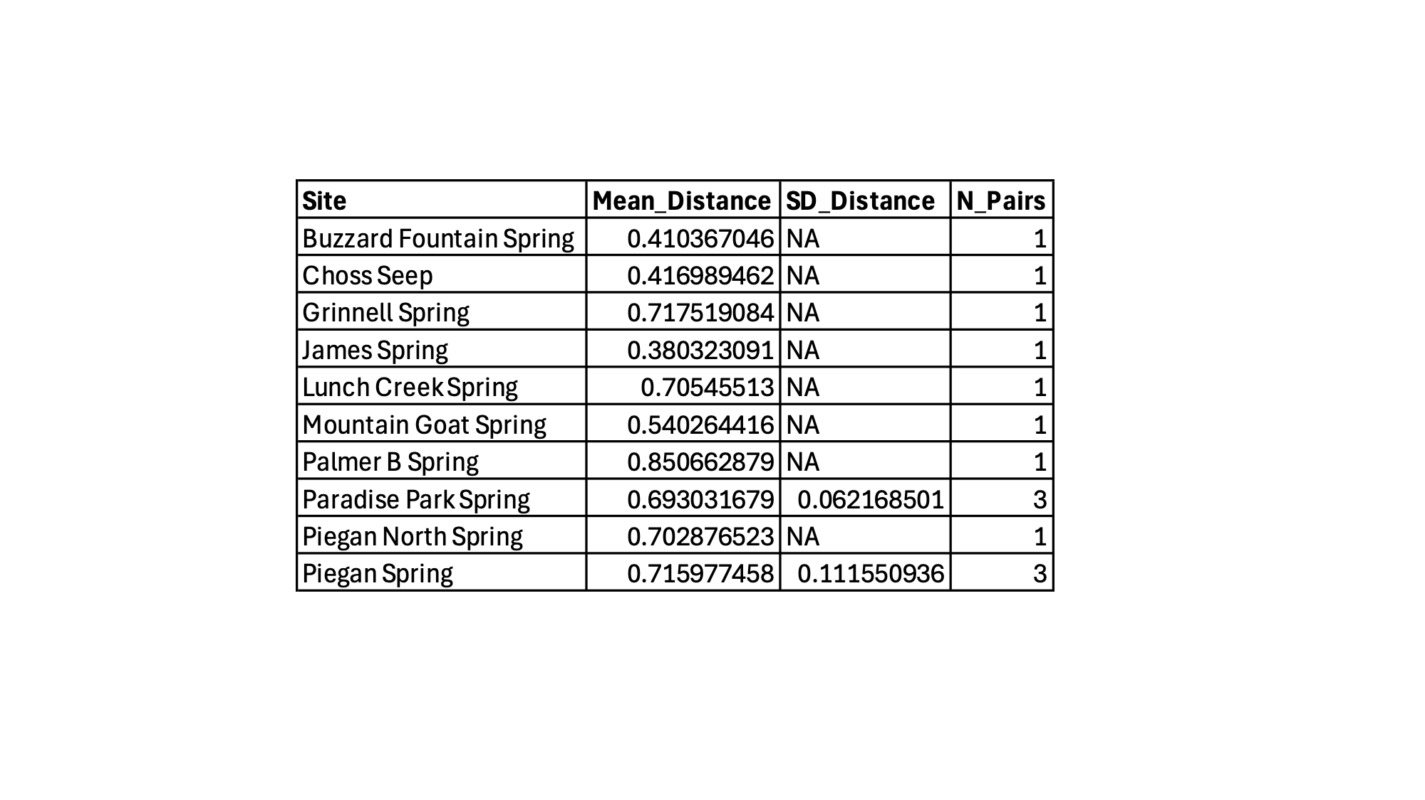

**Table S1**. Mean Bray-Curtis dissimilarities between PCA among **biological replicates** (16S rRNA dataset).

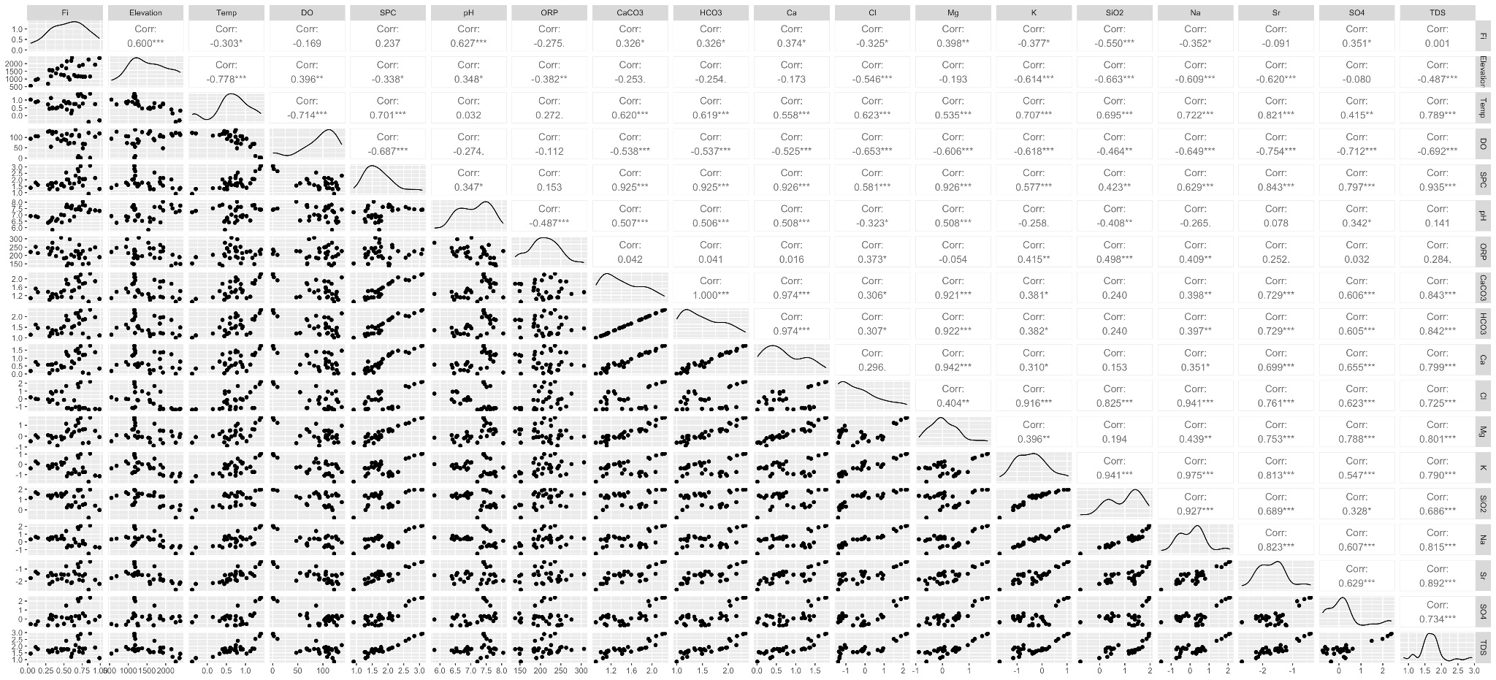

**Figure S9**. **Pairwise correlations and distributions of hydrogeochemical variables used in our microbial PCA, after log₁₀(x+1) (right-skew) (x)2  (left-skew) transformation.**

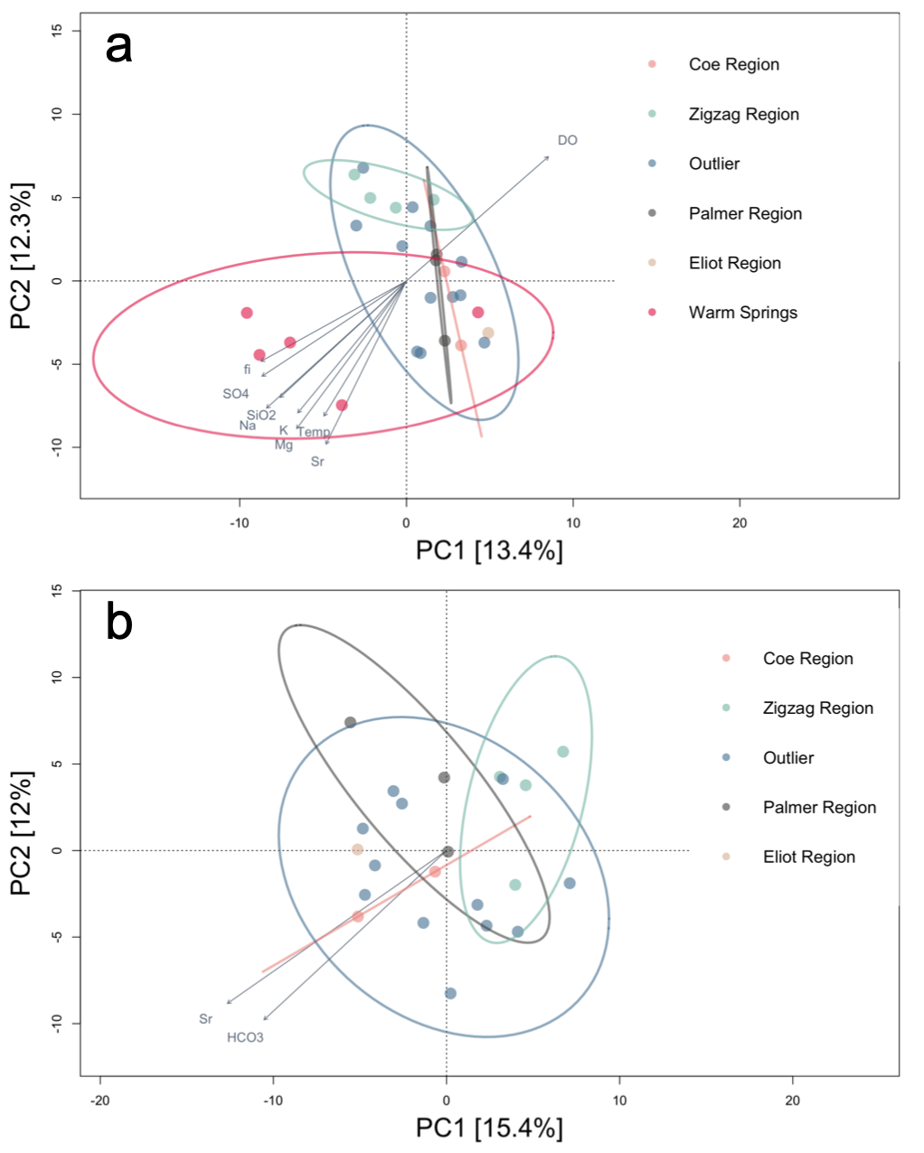

**Figure S10**. Principal component analysis (PCA) of spring and stream microbiome samples from MH grouped by region (**a**) with and (**b**) without the inclusion of Warm Springs. The top two components explained 25.7% and 27.4% of the total variability, respectively. Like Figure 6, Fitted environmental variables represent significant linear regressions (p<0.05) between PC1/PC2 and physicochemical measurements. Ellipses show the standard deviation within each region. We removed covariates (i.e., redundant arrows). In (**a**), SPC, pH, HCO3-, CaCO3, and Ca2+ were contrived with Mg, Cl- with temperature, and TDS with Na+. In (**b**), CaCO3 and HCO3- were redundant.

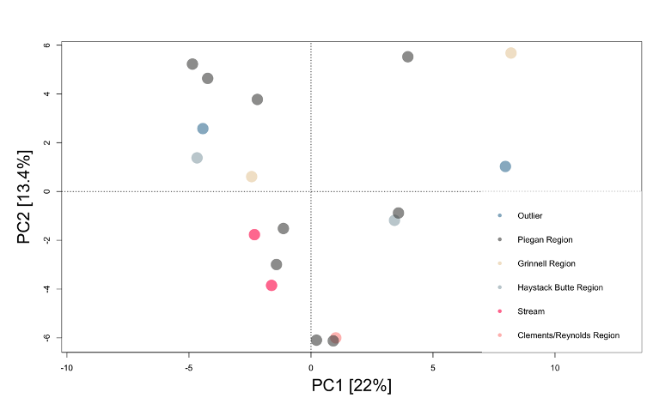

**Figure S11**. Principal component analysis (PCA) of spring and stream microbiome samples from GNP grouped by region (colors and shapes). The top two components explained 35.4% of the total variability. A lack of fitted environmental variables indicates a lack of significant linear regressions (p < 0.05) between PC1/2 and physicochemical measurements. Ellipses show the standard deviation within each region.

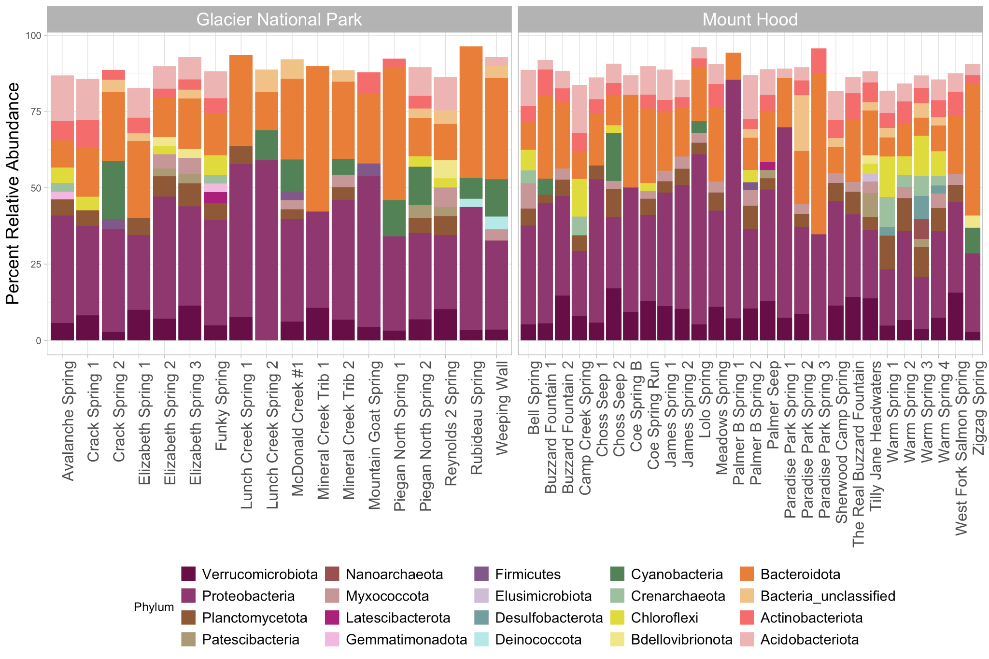

**Figure S12**. Bacterial relative abundance plot using rarefied alpha diversity dataset. Phyla containing < 2% relative abundance in each sample were removed.

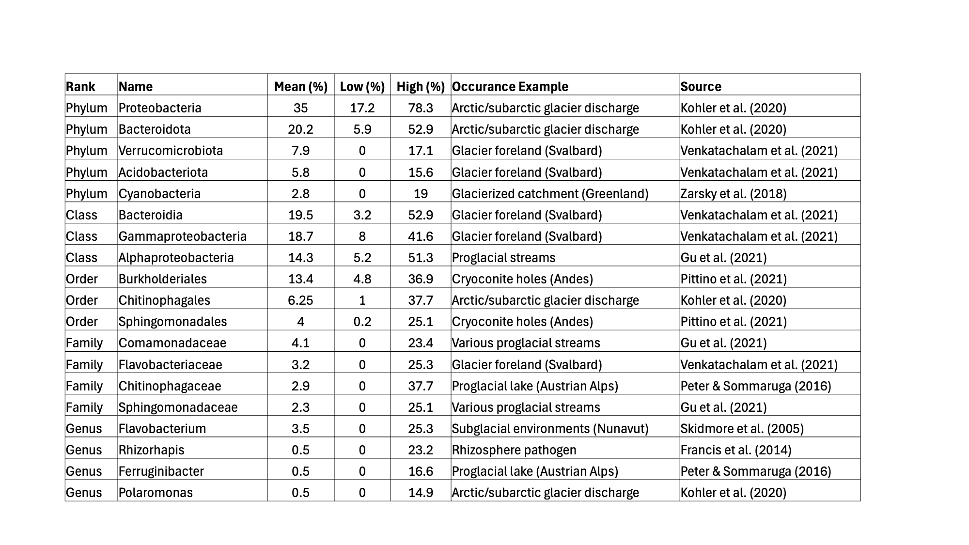

**Table S2**. Dominant taxa across several hierarchical ranks in our rarefied alpha diversity dataset. Mean captures the average percent relative abundance across 45 samples (27 MH and 18 GNP). Low and high values depict the range of abundances observed. Previous occurrences and their corresponding source provide examples of where applicable bacteria have previously been seen.

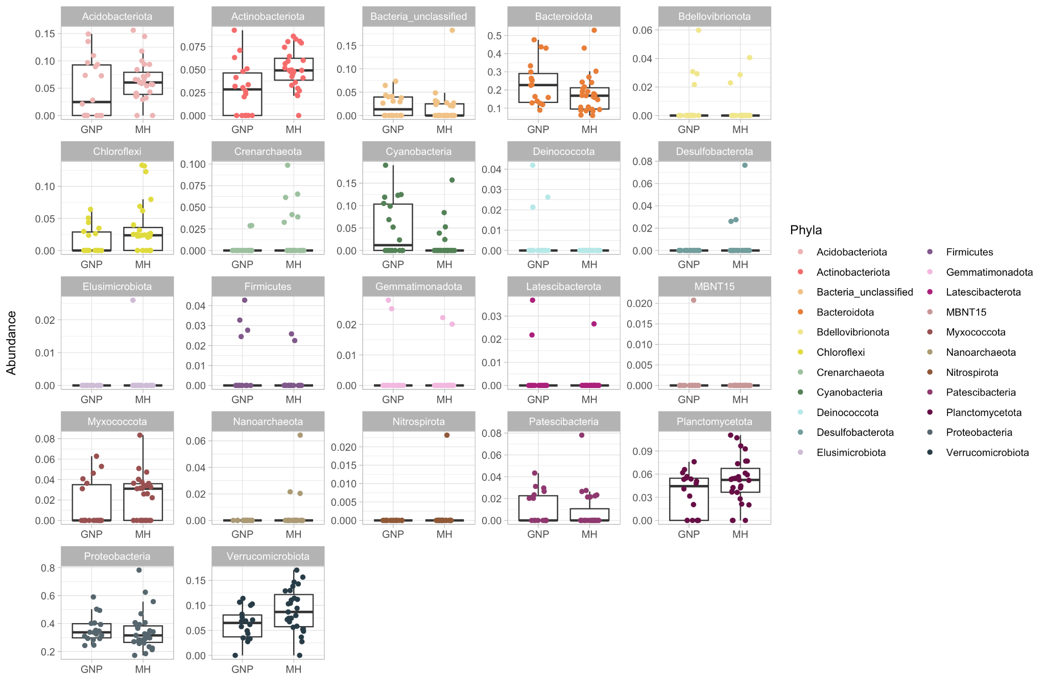

**Figure S13**. Differences in relative phyla abundance (read count) by glacier system (Glacier National Park = GNP; Mount Hood = MH)

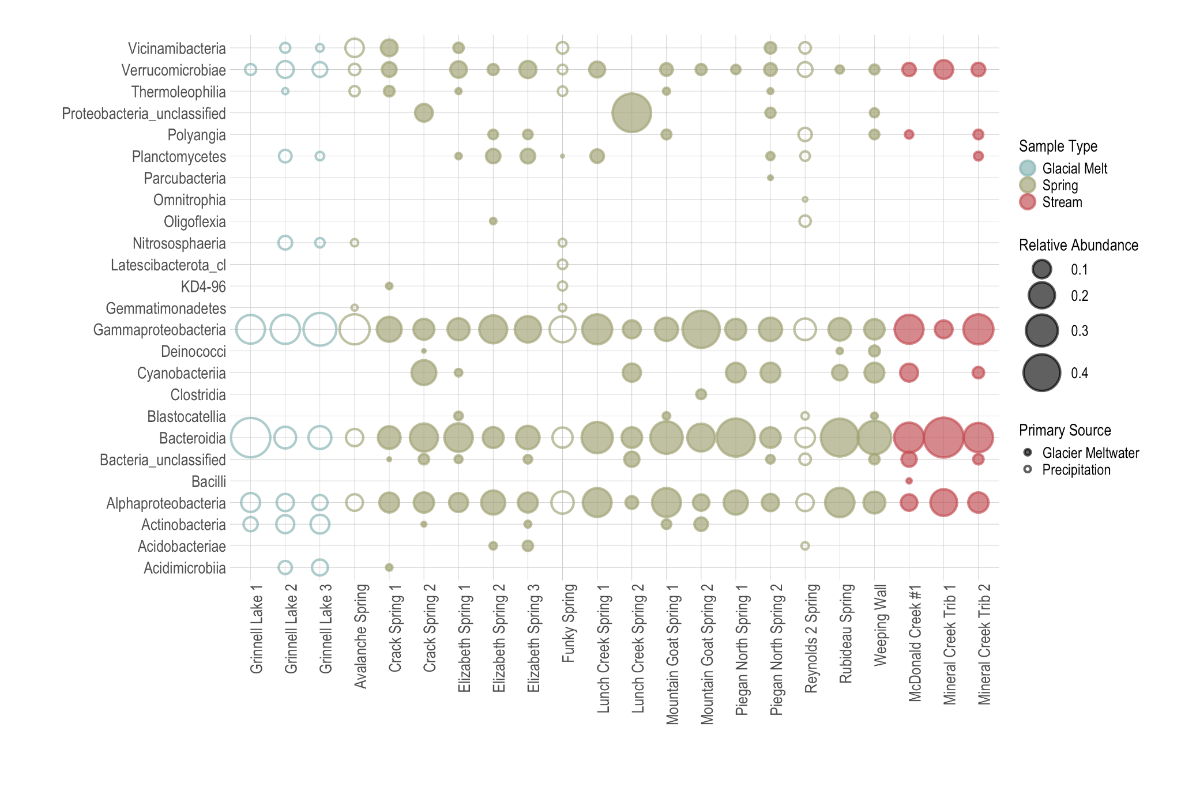

**Figure S14**. **The relative abundance of GNP bacterial Classes varies between sample types (e.g., Springs/Streams vs. End-Members)**.

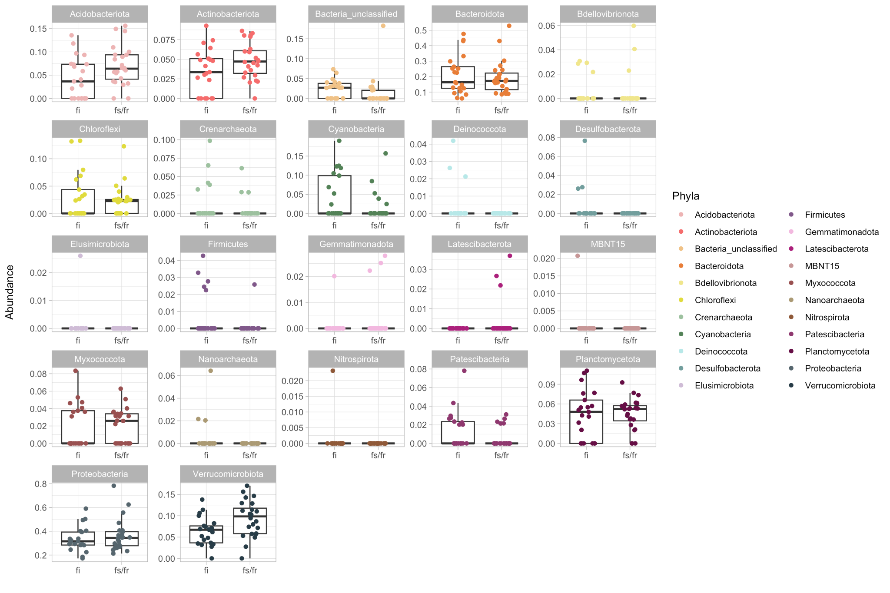

**Figure S15**. Differences in relative phyla abundance (read count) by predominant recharge source (Glacier Meltwater = fi; Precipitation = fs/fr)

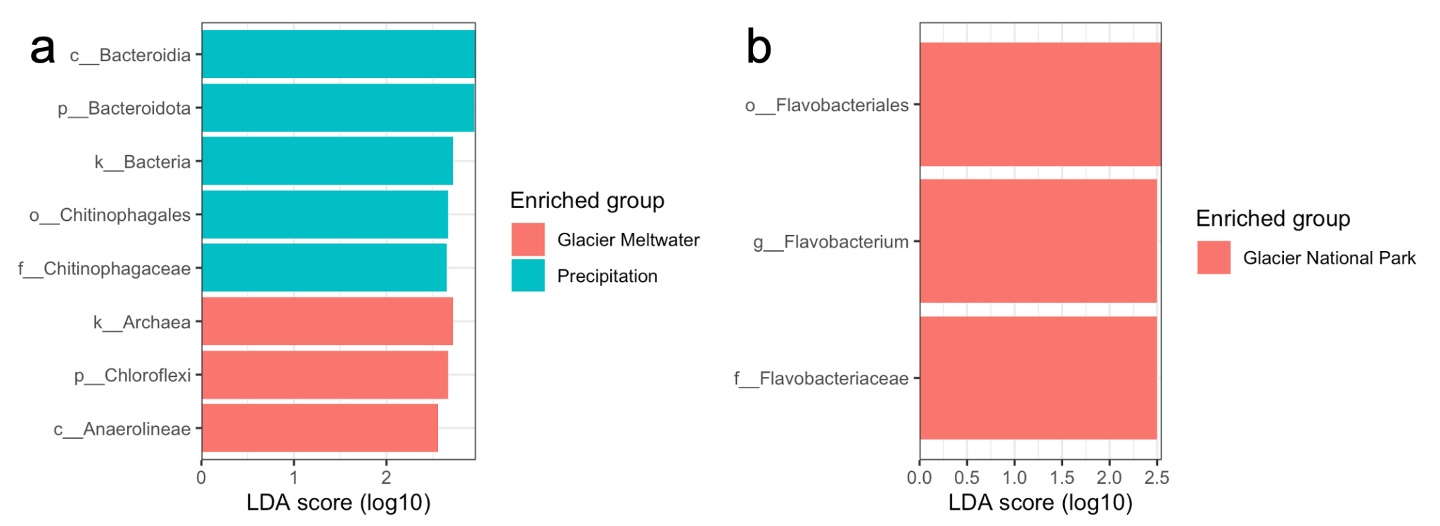

**Figure S16**. Bioindator taxa identified via LEfSe analysis of sourcing in MH (a) and between glacier systems (b).

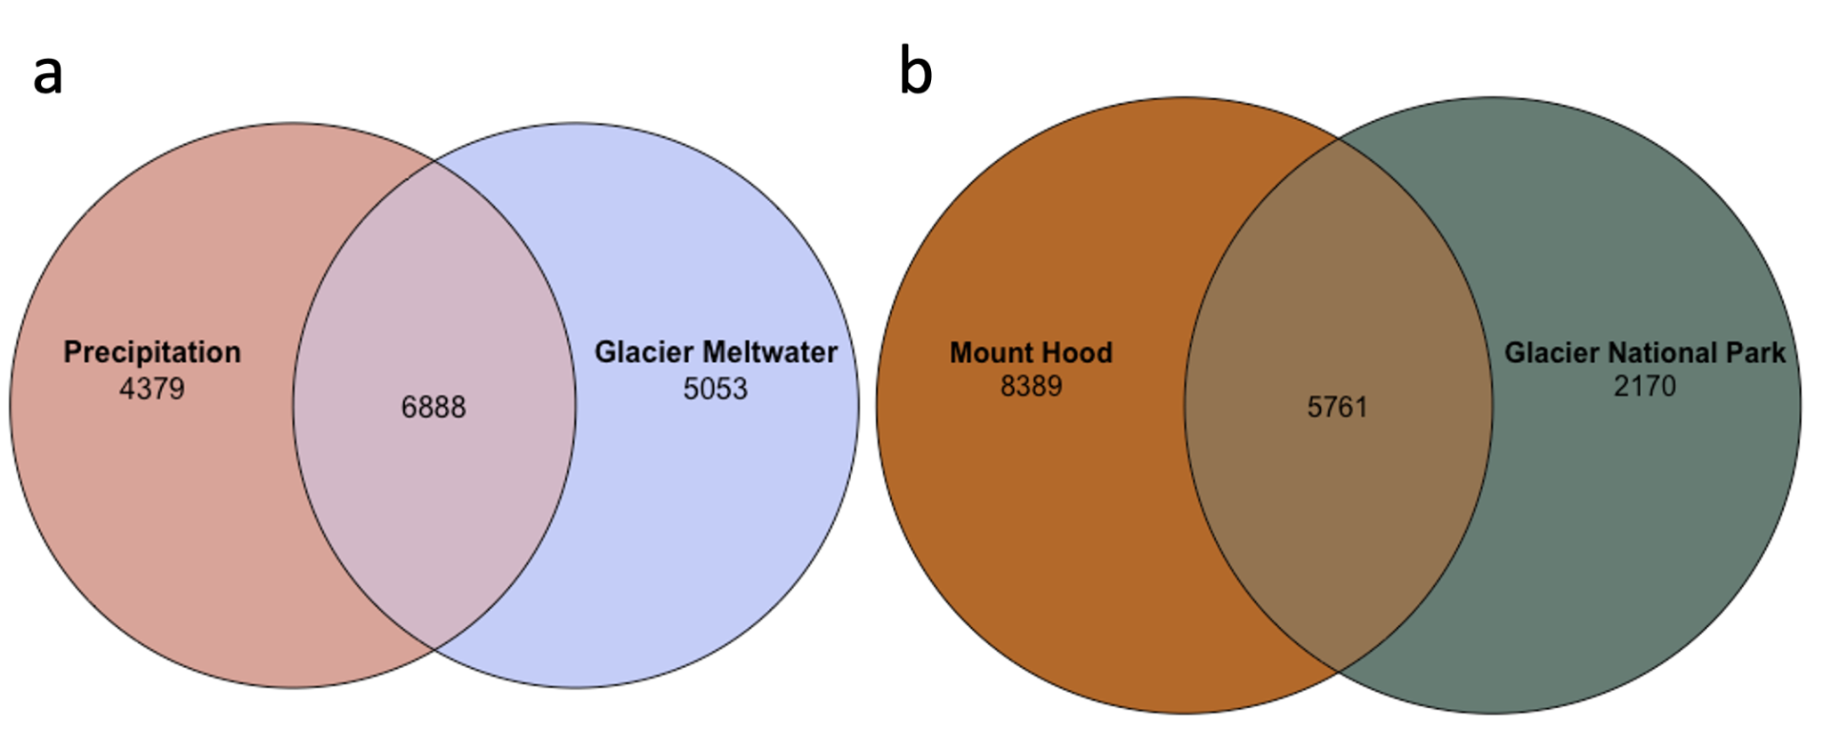

**Figure S17**. Venn diagrams identifying the “core” and “accessory” population of bacterial OTUs from springs and streams in Mount Hood (MH) and Glacier National Park (GNP) by **(a)** primary source (e.g., Glacier Meltwater = fi > 0.6) and **(b)** sampling location. Overlapping quantities capture the number of shared taxa. Unshared values were exclusive to either Precipitation or Glacier Meltwater sourcing, and MH or GNP.

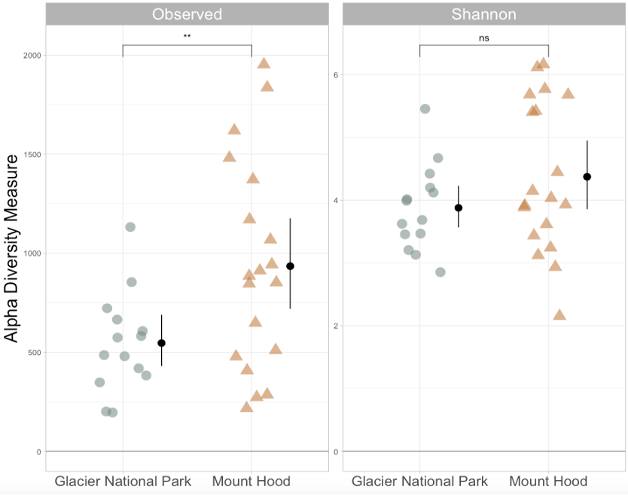

**Figure S18**. Geographic comparison of alpha diversity metrics per our eukaryotic (18S rRNA) dataset.

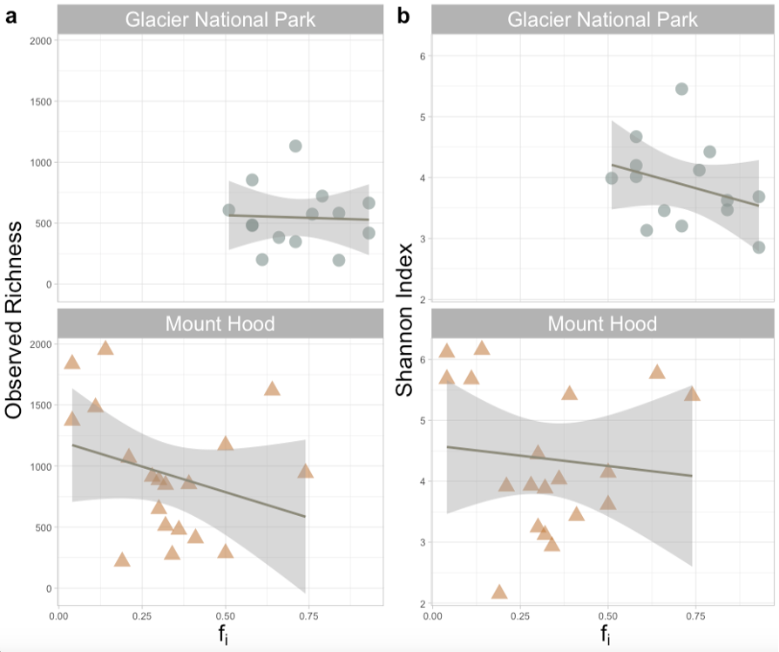

**Figure S19**. Geographic comparison of alpha diversity metrics – in response to the fractional contribution of glacier ice (fi) per our eukaryotic (18S rRNA) dataset.

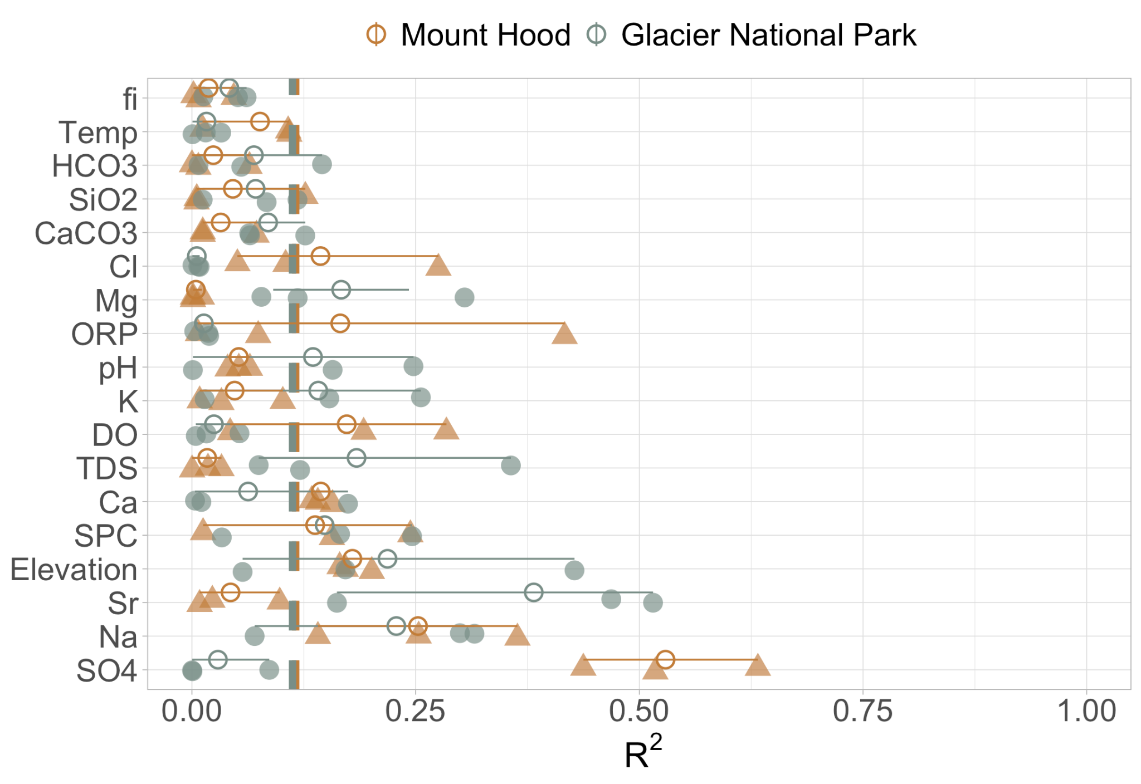

**Figure S20**. Geographic comparison of R2 (predictive power) of various environmental variables using Sperlea et al.’s [2021] machine learning framework, per our eukaryotic (18S rRNA) dataset.

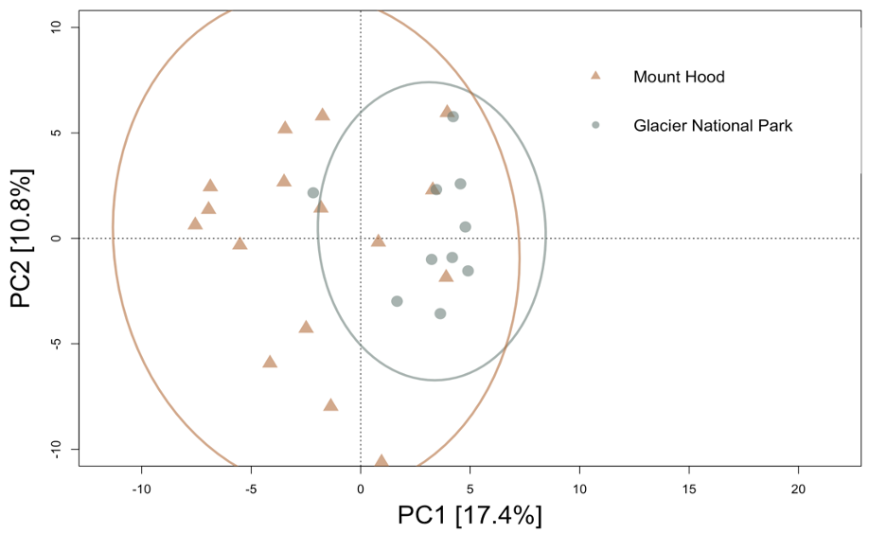

**Figure S21**.Geographic comparison of beta diversity (PCA ordination) per our eukaryotic (18S rRNA) dataset. There were no significant relationships between sample distribution in ordination space and modeled variables.

**REFERENCES**

Miller, J. B., Frisbee, M. D., Hamilton, T. L., & Murugapiran, S. K. (2021). Recharge from glacial meltwater is critical for alpine springs and their microbiomes. *Environmental Research Letters, 16*(6), 64012-. <https://doi.org/10.1088/1748-9326/abf06b>

Nathenson, M. (2004). Springs on and in the vicinity of Mount Hood volcano, Oregon. Open-File Report (United States Geological Survey. 1978).

Scott, W. E., Gardner, C. A., Sherrod, D. R., Tilling, R. I., Lanphere, M. A., & Conrey, R. M. (1997). Geologic history of Mount Hood Volcano, Oregon; a field-trip guidebook. Open-File Report (United States Geological Survey. 1978).

Jefferson, A., Grant, G., & Rose, T. (2006). Influence of volcanic history on groundwater patterns on the west slope of the Oregon High Cascades. *Water Resources Research, 42*(12). <https://doi.org/10.1029/2005WR004812>

Tague, C., & Grant, G. E. (2009). Groundwater dynamics mediate low-flow response to global warming in snow-dominated alpine regions. *Water Resources Research, 45*(7). <https://doi.org/10.1029/2008WR007179>

Bakken-French, N., Boyer, S. J., Southworth, B. C., Thayne, M., Rood, D. H., & Carlson, A. E. (2024). Unprecedented 21st century glacier loss on Mt. Hood, Oregon, USA. *The Cryosphere, 18*(9), 4517–4530. <https://doi.org/10.5194/tc-18-4517-2024>

Horodyski, R. J., Weber, R., Guerrero, J. C., Nagy, B., & Schidlowski, M. (1983). Sedimentary geology and stromatolites of the Middle Proterozoic Belt Supergroup, Glacier National Park, Montana. *Precambrian Research, 20*(2–4), 391–425. <https://doi.org/10.1016/0301-9268(83)90083-9>

Fagre, D.B., McKeon, L.A., Dick, K.A., and Fountain, A.G., 2017, Glacier margin time series (1966, 1998, 2005, 2015) of the named glaciers of Glacier National Park, MT, USA: U.S. Geological Survey data release, <https://doi.org/10.5066/F7P26WB1>.

Hall, M.H.P., & Fagre, D.B. (2003). Modeled Climate-Induced Glacier Change in Glacier National Park, 1850–2100. Bioscience, 53(2), 131–140. [https://doi.org/10.1641/0006-3568(2003)053[0131:MCIGCI]2.0.CO;2](https://doi.org/10.1641/0006-3568(2003)053%5B0131:MCIGCI%5D2.0.CO;2)

Bosson, J. B., Huss, M., & Osipova, E. (2019). Disappearing world heritage glaciers as a keystone of nature conservation in a changing climate. *Earth’s Future, 7*(4), 469–479. <https://doi.org/10.1029/2018EF001139>

Wollenberg, H. A., Bowen, R. E., Bowman, H. R., & Strisower, B. (1979). Geochemical studies of rocks, water, and gases at Mt. Hood, Oregon. LBL - Lawrence Berkeley Laboratory, 7092.

Arendt, C. A., Aciego, S. M., & Hetland, E. A. (2015). An open-source Bayesian Monte Carlo isotope mixing model with applications in Earth surface processes. *Geochemistry, Geophysics, Geosystems : G3, 16*(5), 1274–1292. <https://doi.org/10.1002/2014GC005683>

Gohl, D. M., Vangay, P., Garbe, J., MacLean, A., Hauge, A., Becker, A., Gould, T. J., Clayton, J. B., Johnson, T. J., Hunter, R., Knights, D., & Beckman, K. B. (2016). Systematic improvement of amplicon marker gene methods for increased accuracy in microbiome studies. *Nature Biotechnology, 34*(9), 942–949. <https://doi.org/10.1038/nbt.3601>

Schloss, P. D., Westcott, S. L., Ryabin, T., Hall, J. R., Hartmann, M., Hollister, E. B., Lesniewski, R. A., Oakley, B. B., Parks, D. H., Robinson, C. J., Sahl, J. W., Stres, B., Thallinger, G. G., Van Horn, D. J., & Weber, C. F. (2009). Introducing mothur: Open-Source, Platform-Independent, Community-Supported Software for Describing and Comparing Microbial Communities. *Applied and Environmental Microbiology, 75*(23), 7537–7541. <https://doi.org/10.1128/AEM.01541-09>

Kozich, J. J., Westcott, S. L., Baxter, N. T., Highlander, S. K., & Schloss, P. D. (2013). Development of a Dual-Index Sequencing Strategy and Curation Pipeline for Analyzing Amplicon Sequence Data on the MiSeq Illumina Sequencing Platform. *Applied and Environmental Microbiology, 79*(17), 5112–5120. <https://doi.org/10.1128/AEM.01043-13>

Ghezzi, D., Foschi, L., Firrincieli, A., Hong, P.-Y., Vergara, F., De Waele, J., Sauro, F., & Cappelletti, M. (2022). Insights into the microbial life in silica-rich subterranean environments: microbial communities and ecological interactions in an orthoquartzite cave (Imawari Yeuta, Auyan Tepui, Venezuela). *Frontiers in Microbiology*, 13, 930302–930302. <https://doi.org/10.3389/fmicb.2022.930302>

Oksanen, J., Blanchet, F. G., Friendly, M., Kindt, R., Legendre, P., McGlinn, D., Minchin, P. R., O'Hara, R. B., Simpson, G. L., Solymos, P., Stevens, M. H. H., Szoecs, E., & Wagner, H. (2018). vegan: Community Ecology Package. CRAN [R package version 2.5-2]

Kohler, T. J., Vinsova, P., Falteisek, L., Zarsky, J. D., Yde, J. C., Hatton, J. E., Hawkings, J. R., Lamarche-Gagnon, G., Hood, E., Cameron, K. A., & Stibal, M. (2020). Patterns in Microbial Assemblages Exported From the Meltwater of Arctic and Sub-Arctic Glaciers. *Frontiers in Microbiology, 11*, 669–669. <https://doi.org/10.3389/fmicb.2020.00669>

Vu, V. Q. (2011). ggbiplot: A ggplot2 Based Biplot. R Package Version 0.55. Available online at: <http://github.com/vqv/ggbiplot> (accessed April 13, 2025).

Schloss, P. D., & McMahon, K. (2024). Rarefaction is currently the best approach to control for uneven sequencing effort in amplicon sequence analyses. *mSphere, 9*(2), e0035423–e0035423. <https://doi.org/10.1128/msphere.00354-23>

Gohl, D. M., Vangay, P., Garbe, J., MacLean, A., Hauge, A., Becker, A., Gould, T. J., Clayton, J. B., Johnson, T. J., Hunter, R., Knights, D., & Beckman, K. B. (2016). Systematic improvement of amplicon marker gene methods for increased accuracy in microbiome studies. *Nature Biotechnology, 34*(9), 942–949. <https://doi.org/10.1038/nbt.3601>

Kozich, J. J., Westcott, S. L., Baxter, N. T., Highlander, S. K., & Schloss, P. D. (2013). Development of a Dual-Index Sequencing Strategy and Curation Pipeline for Analyzing Amplicon Sequence Data on the MiSeq Illumina Sequencing Platform. Applied and Environmental Microbiology, 79(17), 5112–5120. <https://doi.org/10.1128/AEM.01043-13>

Schloss, P. D., Westcott, S. L., Ryabin, T., Hall, J. R., Hartmann, M., Hollister, E. B., … Weber, C. F. (2009). Introducing mothur: Open-source, platform-independent, community-supported software for describing and comparing microbial communities. *Applied and Environmental Microbiology, 75*, 7537–7541. doi:10.1128/AEM.01541-09

Glassman, S. I., & Martiny, J. B. H. (2018). Broadscale ecological patterns are robust to use of exact sequence variants versus operational taxonomic units. *mSphere, 3*(4). <https://doi.org/10.1128/MSPHERE.00148-18>

McMurdie, P., Holmes, S. (2013). Phyloseq: An R package for reproducible interactive analysis and graphics of microbiome census data. PloS One, 8(4), E61217.

Sauer, H. M., Hamilton, T. L., Anderson, R. E., Umbanhowar, C. E., & Heathcote, A. J. (2022). Diversity and distribution of sediment bacteria across an ecological and trophic gradient. *PloS One, 17*(3), e0258079–e0258079. <https://doi.org/10.1371/journal.pone.0258079>

Tang, Y., Horikoshi, M., & Li, W. (2016). ggfortify: Unified Interface to Visualize Statistical Results of Popular R Packages. *The R Journal, 8*(2), 474–485. <https://doi.org/10.32614/RJ-2016-060>

Sperlea, T., Kreuder, N., Beisser, D., Hattab, G., Boenigk, J., & Heider, D. (2021). Quantification of the covariation of lake microbiomes and environmental variables using a machine learning‐based framework. *Molecular Ecology, 30*(9), 2131–2144. <https://doi.org/10.1111/mec.1587>2

Cáceres, M. D., & Legendre, P. (2009). Associations between species and groups of sites: indices and statistical inference. *Ecology (Durham), 90*(12), 3566–3574. <https://doi.org/10.1890/08-1823.1>

Cao, Y., Dong, Q., Wang, D., Zhang, P., Liu, Y., & Niu, C. (2022). microbiomeMarker: An R/Bioconductor package for microbiome marker identification and visualization. *Bioinformatics, 38*(16), 4027–4029. <https://doi.org/10.1093/bioinformatics/btac438>

Lamarche-Gagnon, G., Stibal, M., Anesio, A. M., Wadham, J. L., Hawkings, J., Falteisek, L., Vrbická, K., Klímová, P., Žárský, J. D., Kohler, T. J., Bagshaw, E. A., Hatton, J. E., Beaton, A. D., & Telling, J. (2024). Understanding microbial sourcing in Greenland subglacial runoff. *EGUsphere [preprint]*. <https://doi.org/10.5194/egusphere-2024-817>

Love M, Ahlmann-Eltze C, Forbes K, Anders S, Huber W. DESeq2: Differential gene expression analysis based on the negative binomial distribution [Internet]. (2014). Bioconductor version: Release (3.20); 2025 [cited 2025 APR 13]. Available from: <https://bioconductor.org/packages/DESeq2/>

Badri, M., Kurtz, Z. D., Bonneau, R., & Müller, C. L. (2020). Shrinkage improves estimation of microbial associations under different normalization methods. *NAR Genomics and Bioinformatics, 2*(4), lqaa100–lqaa100. <https://doi.org/10.1093/nargab/lqaa100>